BOWEL CANCER SCREENING
PROGRAMME
AWARENESS RESOURCE
FOLDER

Age 60 – 74?
You’re eligible for NHS Bowel Cancer Screening

BOWEL CANCER SCREENING PROGRAMME

BOWEL CANCER SCREENING TEAM:

Accredited Screening Consultants
- Dr Sen, Screening Director
- Dr Brind
- Dr Hebbar
- Dr Rajkumar
- Dr Kurup
- Dr Desai
- Prince Thomas, Nurse Endoscopist, Accredited Colonoscopist
Bowel Cancer Screening Nurses
- Carol Beeston, Service Nurse Lead
- Gloria Garlick
- Edna Beaty
- Deborah Maccioni
- Adrian Black
- Rachel Owen
- Amanda Baggaley
- Wendy Walchester
- Carol Wheatley
Administrative Team
- Angela Power, Bowel Cancer Screening Programme Manager
- Karen Davies, Lead Bowel Cancer Screening Programme Administrator
- Louise Booth, Bowel Cancer Screening Co-ordinator
- Kathleen Pointon, Bowel Cancer Screening Programme Administrator
- Diane Jones, Bowel Cancer Screening Programme Administrator

CONTACT TELEPHONE NUMBERS:
- Office Number: Internal : Ex 76643 (Answerphone)
External: 01782 676643 / 676642

- The HUB Free Phone Number: 0800 707 60 60
Contact Hours:
- 08:00 -16:30 Monday - Friday
- Outside these hours please leave a message and we will call you back

The NHS Bowel Cancer Screening Programme (BCSP) aims to detect bowel cancer at an early stage, in people with no symptoms when treatment is more likely to be effective. The method of screening is by sending men and women from the age of 60 up to their 75th birthday, a test kit in the post; people who are over this age can request a kit from the programme HUB on 0800 707 6060. The test kit detects if there is any blood hidden in small amounts of faeces. An abnormal result does not necessarily mean that cancer has been detected but it does trigger an invitation to have an investigation to find out what is causing the bleeding. www.bowelcanceruk.org

How Are People Screened?
- Polyps and cancers can sometimes bleed, the test kit picks up tiny amounts of blood that may not be seen to the naked eye
- Faecal Immunochemical Test (FIT) kits are sent every 2 years to men and women aged between 60 - 74. People over 75 can request a test kit
- An abnormal result does not necessarily mean that cancer has been found, there can be other causes of a positive result, including polyps, haemorrhoids, inflammation and dietary factors such as read meat and iron rich vegetables.

Bowel Cancer Screening Useful Information
People are Screened that may not have any Symptoms of Bowel Cancer
1:20 will Develop Bowel Cancer
The 4th Most Common Cancer

Why Screen for Bowel Cancer?

The 2nd Cause of Cancer Death
Regular Screening can Reduce the Risk of Dying from Bowel Cancer by 16%
Screening can Prevent Cancer from
Developing by Removing Polyps
If caught early, Treatment can be More Effective
Faecal Immunochemical Test (FIT) kit
Summary of Test Kit Results:
Normal | This occurs in about 98 of 100  This means that no blood has been detected in the Test Kit  These people will be sent another kit in 2 years until their 75th birthday
Unclear | This occurs in about 4 of 100  This means there is a slight suggestion of blood and will need to be sent another test kit. They may go on to get a normal or abnormal result
Abnormal | This occurs in about 2 of 100  This means that blood has been detected. They will be offered a clinic appointment to see a bowel cancer screening nurse where they will be offered a colonoscopy
What the Colonoscopy Procedure Involves:
- A flexible scope is passed around and examines the large bowel
- Air is inflated into the bowel so good visualization is made
- It looks for abnormalities such as inflammation, polyps and cancers
- Samples can be taken from abnormalities
- If polyps are observed they can be removed during the colonoscopy
- Sedation and Gas and Air (Entonox) is offered to comfort the patient

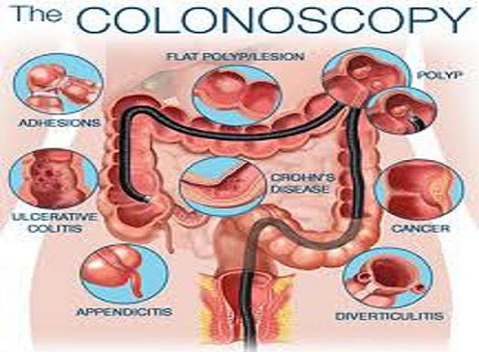

For every 100 people having a colonoscopy
13 will have a normal test | This means that no cancer or polyps have been found
25 will have minor findings | No additional treatment
53 will have adenomas (minor findings) | Which if removed can prevent cancer
9 will have cancer | Treatment required
(BCSP, 2021)

What Are Polyps?
- The lining of the bowel is constantly being renewed. Sometimes cells grow too quickly and form a polyp
- There are certain types of polyps called adenomas which can turn into cancer over a number of years
- There are a small number of polyps which may have cancer cells within them.
If polyps are removed bowel cancer can be prevented.
- Depending on the number and size of polyps, patients can be offered follow- up procedures.

What Affects the Risk of Cancer?
- Both men and women are at risk
- Bowel cancer risk increases with age, around 8 in 10 are diagnosed over 60
- People with family history are at greater risk of developing cancer
- People who do little exercise, are overweight, have a diet high in red meat and low in fruit, vegetables and fibre are more at risk
- People who smoke and/or drink
- People who have diagnosed Colitis or Crohns disease are at a higher risk of developing bowel cancer

What Are the Symptoms of Bowel Cancer
- A change in bowel habit
- Abdominal pain/ discomfort
- Bleeding
- Weight loss and tiredness
- A lump in the abdomen
- ANY SYMPTOMS SHOULD BE REPORTED TO THE GP
Every 15 minutes in the UK someone is diagnosed with bowel cancer

What you can do To Reduce Your Risk of Bowel Cancer
- Do more exercise
- Stop smoking
- Drink less alcohol
- Eat more fruit and vegetables
- Increase your fibre in your diet
- Cut down on red and processed meat
- Drink more water

References; See attached

