Allied Health Professionals Day 14th October 2023
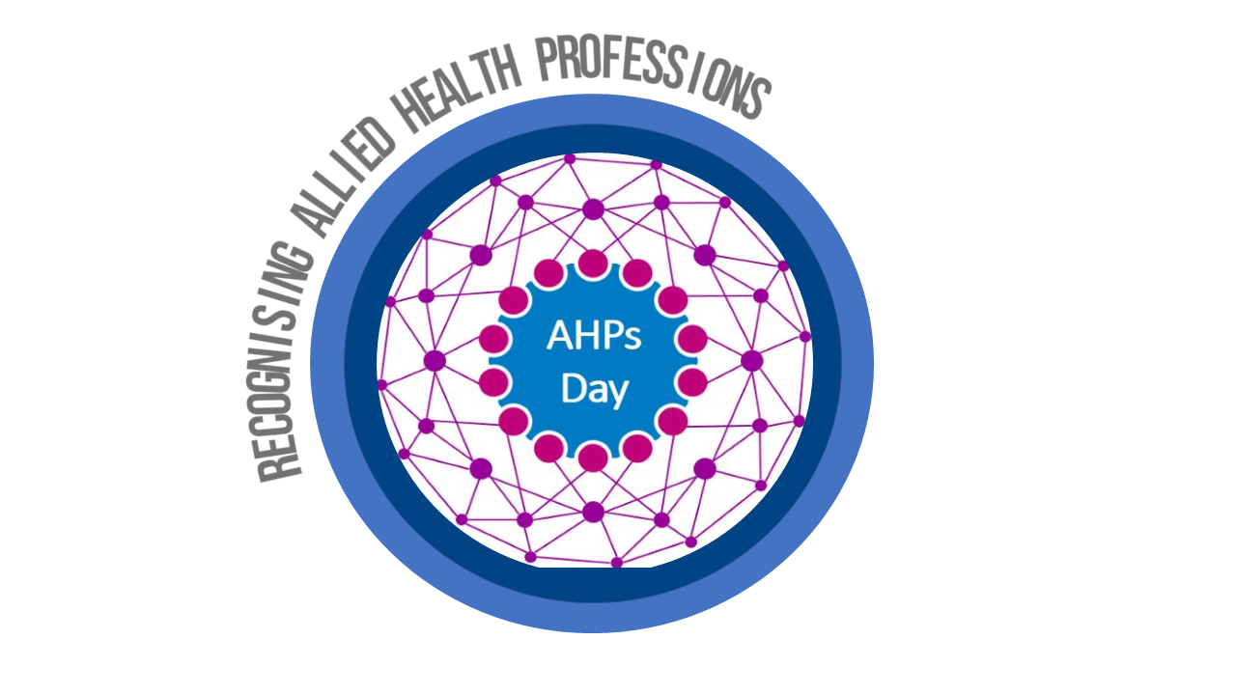

Hello…..I am a Drama Therapist

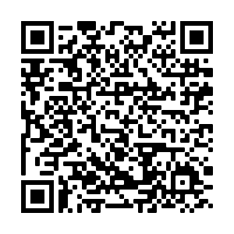

Find out more by
scanning the QR code

