Allied Health Professionals Day 14th October 2023

Hello…..I am a Podiatrist

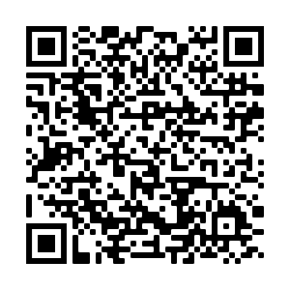

Find out more by
scanning the QR code

