Allied Health Professionals Day October 14th 2023
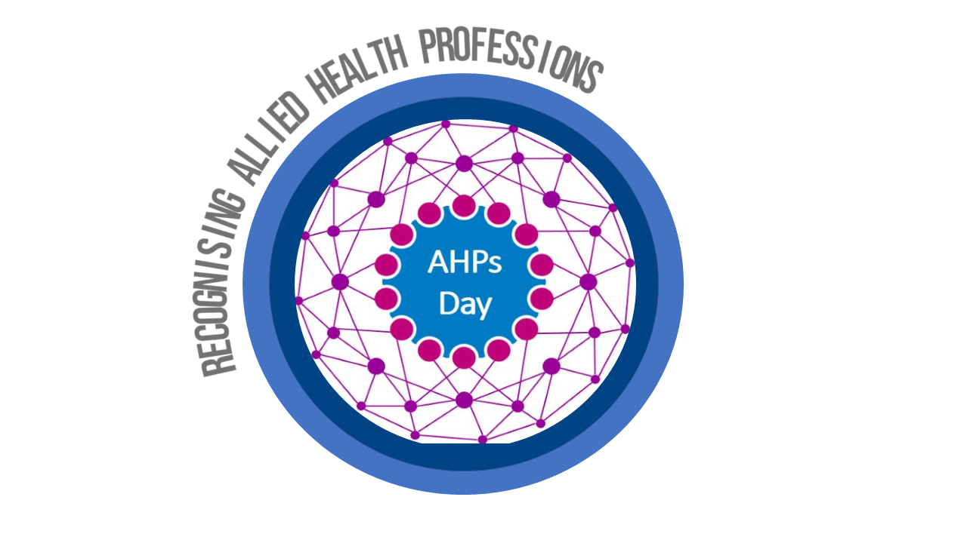

Hello…..I am an Occupational
Therapist

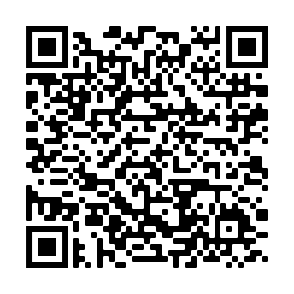
Find out more by
scanning the QR code

