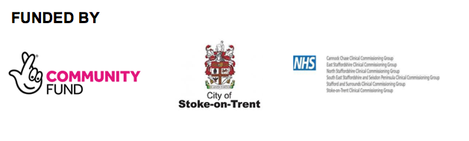

**Adult Referral Form**

|  |  |  |  |
| --- | --- | --- | --- |
| Referrer Details |  |  |  |
| Referred by Self/Organisation & Address |  | Telephone No. |  |
| Has the Carer given permission to share |  | Date |  |

|  |  |  |  |
| --- | --- | --- | --- |
| Carers Details | | | |
| Name Address & Postcode |  | Gender | Male  Female |
| Telephone No. |  | Date of Birth |  |
| Local Authority the carers council tax is paid to |  | Ethnicity |  |
| Medical Conditions |  | GP Surgery |  |

|  |  |
| --- | --- |
| Cared for details | |
| Name |  |
| Relationship to Carer |  |
| Medical Conditions |  |
| Local Authority the cared for council tax is paid to |  |

|  |
| --- |
| Overview of the Case Background (please give further details of your caring role and what support is needed) |
|  |

|  |  |  |  |
| --- | --- | --- | --- |
| Support Needed | | | |
| One to One Support |  | Carers Groups |  |
| Information Only |  | Carers Wellbeing |  |
| Emotional Support |  | Other |  |

|  |  |  |  |  |
| --- | --- | --- | --- | --- |
| Permission to Share Information | | | | |
| For us to help you with your referral we need to record details of your case. These details contain your personal and sensitive data such as address and contact details. To comply with the Data Protection Act (2018) we must tell you how we use this data and ask for your permission. By signing this form, you are providing your permission for us to process your data.  Any information you share with us will be kept safe and secure and processed in line with the Data Protection Act 2018 and our privacy policy. This can be seen on our website [www.carersfirst.com](http://www.carersfirst.com) or you can request a copy from us by calling NSC on 01782 793100  Everything you tell us will be treated confidentially, however, if a safeguarding risk is identified this will be shared with the Local Safeguarding Board and/or Social Care i.e. if you disclose to us that there is a significant risk of harm to you or another person. In dealing with your case we may also like to refer you into other organisations for additional support, a third party contact will only be made if it relates to yourcase and with your permission. We may require a separate consent to act on your behalf, if this is needed.  **Please note:** Nsc is commissioned to deliver the All Age Carers Support Service by Stoke City Council and the Clinical Commissioning Group (CCG), and that all data is owned by them for the life of the contract. They will be able to attain all records that we hold consent for. Any consent that is not given will require us to remove you from the system and stop our support. | | | | |
| I agree/disagree for my information to be shared with the person for whom I care | Agree |  | Disagree |  |
| I agree/disagree for my information to be shared with any third party organisation/person who will provide services for me | Agree |  | Disagree |  |

|  |  |  |  |
| --- | --- | --- | --- |
| **Carers/Professionals Agreement** | | | |
| I confirm that I have been fully involved in the completion of this form and that this accurately reflect issues discussed.  I understand that this document contains a summary of support needs and that it is not a commitment to provide services. | | | |
| Carers/Professionals Signature |  | Date |  |

|  |
| --- |
| **For professional use only** |
| Are there any known risks our support staff should be aware of prior to visiting this Carer?  Yes No Please circle or highlight  Comments |

**Please return the completed form to :**

**North Staffs Carers, Trent House, 234 Victoria Road,**

**Stoke-on-Trent, ST4 2LW Tel : 01782 793100 Email : nscreferrals@carersfirst.com**