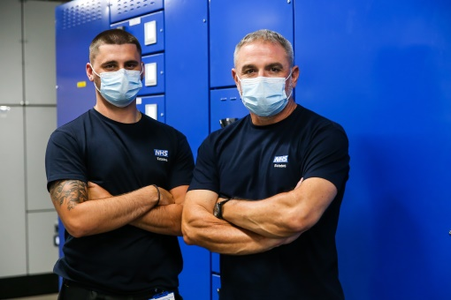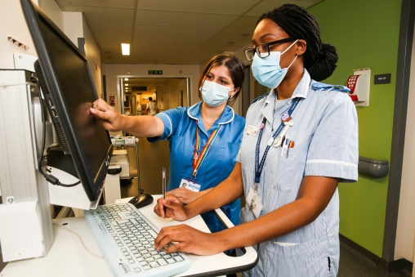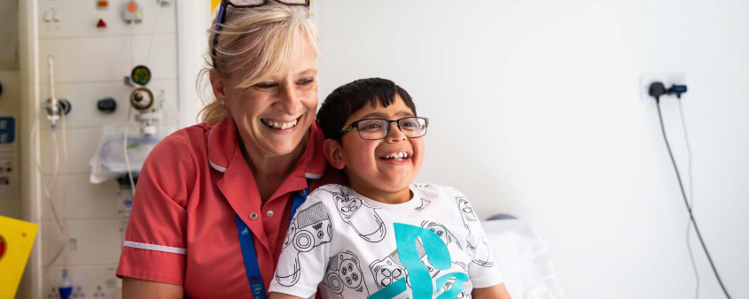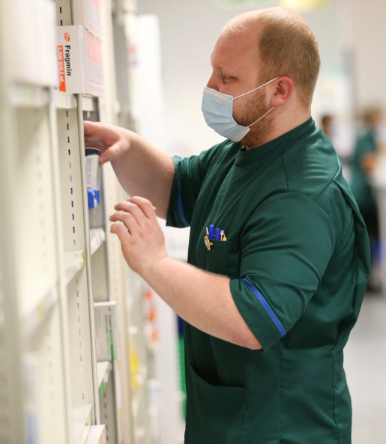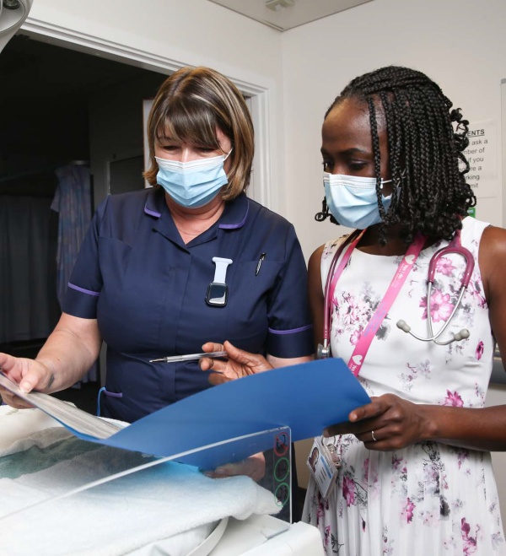

**Patient Safety Incident Response Plan**

2023 / 2025





Contents

**1. Purpose, scope, aims and objectives** 3

**1.1 Purpose** 3

**1.2 Scope** 3

**2. Situation Analysis – National** 5

**3. Situational analysis – local** 7

3.2.1 The current top 10 local priorities/risk register for PSII are: 9

**3.3 Strategic Plan** 9

**4. Patient safety incident investigations** 11

**4.2 Selection of patient safety incidents for PSII** 11

**4.3 Timescales for patient safety PSII** 12

**4.4 Nationally-defined priorities to be referred for PSII or review by another team** 12

**4.5 Nationally-defined incidents requiring local PSII** 13

**4.6 Locally-defined incidents requiring local PSII** 14

**4.7 Thematic analysis following the completion of a small number individual investigations of similar patient safety incidents** 15

**4.8 Patient safety improvement plans underway** 16

**5. Selection of incidents for review** 18

**6. Patient Safety Incident reporting arrangements** 21

**7. Mechanisms to develop and support improvements following PSIIs** 23

**8. Evaluating and monitoring outcomes of PSIIs, Reviews** 25

**9. Complaints and appeals** 26

**1. Purpose, scope, aims and objectives**

**1.1 Purpose**

1.1.1 This patient safety incident response plan (PSIRP) sets out how the **University Hospitals of North Midlands NHS Trust** will seek to learn from patient safety incidents reported by staff and patients, their families and carers as part of our work to continually improve the quality and safety of the care we provide.

1.1.2 This plan will help us measurably improve the efficacy of our local patient safety incident investigations (PSIIs) by:

1. refocusing PSII towards a systems approach[1] and the rigorous identification of interconnected causal factors and systems issues
2. focusing on addressing these causal factors and the use of improvement science[2] to prevent or continuously and measurably reduce repeat patient safety risks and incidents
3. transferring the emphasis from the quantity to the quality of PSIIs such that it increases our stakeholders’ (notably patients, families, carers and staff) confidence in the improvement of patient safety through learning from incidents
4. demonstrating the added value from the above approach.

**1.2 Scope**

1.2.1 There are many ways to respond to an incident. This document covers responses conducted solely for the purpose of system learning and improvement.

1.2.2 This document should be read alongside the introductory Patient Safety Incident Response Framework (PSIRF) 2020, which sets out the requirement for this plan to be developed.

1.2.3 We have developed the planning aspects of this PSIRP with the assistance and approval of the organisation’s local commissioner(s).

1.2.4 The aim of this approach is to continually improve. As such this document will be reviewed annually to start with.

**1.3 Strategic aims**

1.3.1 Improve the safety of the care we provide to our patients, and improve our patients’, their families’ and carers’ experience of it.

1.3.2 Further develop systems of care to continually improve their quality and efficiency.

1.3.3 Improve the experience for patients, their families and carers wherever a patient safety incident or the need for a PSII is identified.

1.3.4 Improve the use of valuable healthcare resources.

1.3.5 Improve the working environment for staff in relation to their experiences of patient safety incidents and investigations.

**1.4 Strategic objectives**

1.4.1 Act on feedback from patients, families, carers and staff about the current problems with patient safety incident response and PSIIs in the NHS.

1.4.2 Develop a climate that supports a just culture and an effective learning response to patient safety incidents.

1.4.3 Develop a local board-led and commissioner and integrated care system (ICS)/sustainability and transformation partnership (STP)-assured architecture around PSII and alternative responses to patient safety incidents, which promotes ownership, rigour, expertise and efficacy.

1.4.4 Make more effective use of current resources by transferring the emphasis from the quantity of investigations to a higher quality, more proportionate response to patient safety incidents, as a whole. The aim is to:

* make PSIIs more rigorous and, with this, identify causal factors and system-based improvements
* engage patients, families, carers and staff in PSII and other responses to incidents, for better understanding of the issues and causal factors
* develop and implement improvements more effectively
* explore means of effective and sustainable spread of improvements which have proved demonstrably effective locally.

**2. Situation Analysis – National**

2.1.1 Many millions of people are treated safely and successfully each year by the NHS in England, but evidence tells us that in complex healthcare systems things will and do go wrong, no matter how dedicated and professional the staff.

2.1.2 When things go wrong, patients are at risk of harm and many others may be affected. The emotional and physical consequences for patients and their families can be devastating. For the staff involved, incidents can be distressing and members of the clinical teams to which they belong can become demoralised and disaffected. Safety incidents also incur costs through lost time, additional treatment and litigation. Overwhelmingly these incidents are caused by system design issues, not mistakes by individuals.

2.1.3 Historically, the NHS has required organisations to investigate each incident report that meets a certain outcome threshold or ‘trigger list’. When this approach was developed it was not clear that:

a. Luck often determines whether an undesired circumstance translates into a near miss or a severe harm incident. As a result, focusing most patient safety investigation efforts on incidents with the most severe outcome does not necessarily provide the most effective route to ‘organisational learning’.[3]

b. There is no clear need to investigate every incident report to identify the common causes and improvement actions required to reduce the risk of similar incidents occurring. To emphasise this point, it has been highlighted that in-depth analysis of a small number of incidents brings greater dividends than a cursory examination of a large number.

2.1.4 An increased openness to report patient safety issues has also led to an ever-growing number of incidents being referred for investigation. NHS organisations are now struggling to meet the number of requests for investigation into similar types of incident with the level of rigour and quality required. Available resources have become inundated by the investigation process itself – leaving little capacity to carry out the very safety improvement work the NHS originally set out to achieve.

2.1.5 In addition, the remit for patient safety incident investigation (PSII) has become unhelpfully broad and mixed over time. This originates from an attempt to be more efficient by addressing the many and varied needs of different types of investigation in a single approach. Sadly, the very nature and needs of some types of investigation (eg professional conduct or fitness to practise; establishing liability or avoidability; or establishing cause of death) have frustrated the original patient safety aim and blocked the system learning the NHS set out to achieve.

2.1.6 Many other high-profile organisations now identify and describe their rationale for deciding which incidents to investigate from a learning and improvement perspective. While some industry leaders describe taking a risk-based approach to safety investigation (eg the Rail Accident Investigation Branch and Air Transport Safety Board), others list the parameters that help their decision-making processes (the police, Parliamentary Health Service Ombudsman and Healthcare Safety Investigation Branch).

2.1.7 We need to remove the barriers in healthcare that have frustrated the success of learning and improvement following a PSII (eg mixed investigation remits, lack of dedicated time, limited investigation skills). We also need to increase the opportunity for continuous improvement by:

a. improving the quality of future PSIIs

b. conducting PSIIs purely from a patient safety perspective

c. reducing the number of PSIIs into the same type of incident

d. aggregating and confirming the validity of learning and improvements by basing PSIIs on a small number of similar repeat incidents.

2.1.8 This approach will allow NHS organisations to consider the safety issues that are common to similar types of incident and, on the basis of the risk and learning opportunities they present, demonstrate that these are:

a. being explored and addressed as a priority in current PSII work or

b. the subject of current improvement work that can be shown to result in progress or

c. listed for PSII work to be scheduled in the future.

2.1.9 In some cases where a PSII for system learning is not indicated, another response may be required. Options that meet the needs of the situation more appropriately should be considered; these are listed in Section 5.

**3. Situational analysis – local**

**3.1 Results of a review of activity and resources**

3.1.1 Patient safety incident investigation activity based on the current Serious Incident Framework, January 2018 to December 2022:

|  |  | Definition | 2020 | 2021 | 2022 |
| --- | --- | --- | --- | --- | --- |
| **National Priorities** | Incident resulting in death | Serious incident requiring investigation which met the standard investigation timeframe and resulted in patient’s death | 13 | 18 | 25 |
| Never Events | Incident meeting criteria for never events framework and reported to STEIS | 2 | 2 | 7 |
| **Local Patient Priorities** | Serious Incidents Requiring Investigation | Serious incident requiring investigation which met the standard investigation timeframe | 103 | 115 | 126 |
| Patient Safety Incident Reviews | Including moderate harm incidents meeting the requirement for Duty of Candour; not meeting SI criteria | 106 | 116 | 246 |
| Patient Safety Incident Validation | Patient safety incidents of low / no harm requiring validation at department / ward level | 18,127 | 19,994 | 20,914 |

3.1.2 The patient safety incident risks for this organisation have been profiled using organisational data from recent; patient safety incident, legal claims, Coroners findings, complaints, clinical reviews of services, mortality thematic reviews, staff and service user survey results, Care Excellence Framework feedback and safeguarding reviews

3.1.3 A review of the resource and activity associated with the current Serious Incident Framework for the period 2019 to 2023 has been undertaken to determine how many PSIIs can be supported during 2023/2024. This review was carried out alongside the NHS National standards for patient safety investigation to ensure that all future PSIIs are compliant with these standards.

3.1.4 In addition, a review has been completed to determine the current level of resource for Patient Safety Reviews, including pressure ulcers and falls. This supports planning of appropriate responses – using different review techniques – where PSII is not indicated.

3.1.5 In order to meet the requirements of the new NHS National Standards for Patient Safety Investigation we will:

* Develop a gap analysis based on the national PSII Standards to identify potential shortfalls in dedicated PSII personnel, seniority, PSII skills etc.
* Assign an appropriately trained member of the Executive Team to oversee delivery of the PSII standards and support the sign off of all PSIIs.
* Provide Being Open training for all board members.
* Provide access to update training for current staff who provide the incident investigation oversight function on use of updated response tools, use of improvement approaches and utilisation of the national report template.
* Identify an appropriate training provider for training new investigators of PSII’s in the Trust to the standard required by PSIRF.
* Use a targeted approach to identify a number of investigators from a range of professional backgrounds i.e. medical, nursing, AHP.
* Produce new documentation for patients, families and staff members involved in patient safety incidents and ensure they are available on a public-facing area of our website
* Negotiate time in job plans for a core group of senior clinical staff to undertake PSII investigations every year.

**3.2 Conclusions from review of the local patient safety incident profile**

3.2.1 The current top 10 local priorities/risk register for PSII are:

|  | **Incident type** | **Specialty** |
| --- | --- | --- |
| 1 | Falls | Trust Wide |
| 2 | Hospital Acquired Pressure Ulcers | Trust Wide |
| 3 | Identification and Escalation of the Deteriorating Patient | Trust Wide |
| 4 | Diagnosis failed / delayed | Trust Wide |
| 5 | Omission of critical medicines | Trust Wide |
| 6 | Patient Flow | Trust Wide |
| 7 | Handover of Care | Trust Wide |
| 8 | Failure to act upon / interpret results | Trust Wide |
| 9 | Maternal Readmission | Obstetrics |
| 10 | Medication error – DOAC / Insulin | Trust Wide |

**3.3 Strategic Plan**

3.3.1

a. Based on the gap analysis and current resources the Trust has planned to undertake up to 30 patient safety incident investigations during the 12 months running October 2023 to September 2024.

b. Based on historic incident reporting data it is anticipated that of the 30, 25 will be ‘national priority’ patient safety incident investigations during the 12 month period.

c. The Trust has therefore identified 5 priority areas for “local priority” patient safety incident investigations for the next 12 months. The 5 priority areas are outlined within section 4.6.1 of this document.

d. All subsequent incidents falling outside each priority area will be reviewed by one of the alternate incident responses outlined in Section 5. However, it should be noted that if it is felt that there is potential for significant new learning then a full patient safety incident investigation will be undertaken.

e. Clinical effectiveness processes such as clinical audits, national reviews and Learning from Death data will continue to be monitored to ensure any new patient safety risks are identified and acted upon in a timely manner.

f. The summary PSIRP will be available on the Trust’s website making it accessible to patients, relatives, carers and wider stakeholders.

3.3.2 For each comprehensive PSII the Trust will:

1. Ensure each PSII is conducted separately, in full and to a high standard, by a team whose lead investigator is an experienced Band 7 / 8 and has received a minimum of two days’ training.
2. Refer to training and the [national PSII standards](https://improvement.nhs.uk/resources/patient-safety-investigation/) and conduct PSIIs as per the plan and in line with national good practice for PSII.
3. Use the national standard template to report the findings of the PSIIs.
4. Identify common, interconnected, deep-seated causal factors (not high-level themes or problems).

3.3.3 For each group of PSIIs dedicated to a similar/narrow focus incident type the Trust will:

1. Design strong/effective improvements to sustainably address common interconnected causal factors.
2. Develop an action plan for implementation of the planned improvements.
3. Monitor implementation of the improvements.
4. Monitor effectiveness of the improvements over time.
   * 1. The Trust will introduce a system to monitor the quality of PSII findings and progress against this PSIRP, ensuring that the following questions are routinely considered:

a. Are the actions likely to achieve improvement?

b. Is there evidence of improvement?

**4. Patient safety incident investigations**

**4.1 PSII Overview**

4.1.1 PSIIs are conducted for systems learning and safety improvement. This is achieved by identifying the circumstances surrounding incidents and the systems-focused, interconnected causal factors that may appear to be precursors to patient safety incidents. These factors must then be targeted using strong (effective) system improvements to prevent or continuously and measurably reduce repeat patient safety risks and incidents.

4.1.2 There is no remit in PSII to apportion blame or determine liability, preventability or cause of death.

4.1.3 There are several other types of investigation which, unlike PSIIs, may be conducted for or around individuals. Examples include complaints, claims, human resource, professional regulation, coronial or criminal investigations. As the aims of each of these investigations differ, they need to continue to be conducted as separate entities to be effective in meeting their specific intended purposes.

**4.2 Selection of patient safety incidents for PSII**

4.2.1 In view of the above, the selection of incidents for PSII is based on the:

A. Actual and potential impact of the incident’s outcome (harm to people, service quality, public confidence, products, funds, etc)

B. Likelihood of recurrence (including scale, scope and spread)

C. Potential for new learning in terms of:

* Enhanced knowledge and understanding of the underlying factors
* Improved efficiency and effectiveness (control potential)
* Opportunity to influence wider system improvement.

**4.3 Timescales for patient safety PSII**

4.3.1 Where a PSII for learning is indicated, the investigation must be started as soon as possible after the patient safety incident is identified.

4.3.2 PSIIs should ordinarily be completed within one to three months of their start date.

4.3.3 In exceptional circumstances, a longer timeframe may be required for completion of the PSII. In this case, any extended timeframe should be agreed between the healthcare organisation with the patient/family/carer.

4.3.4 No local PSII should take longer than six months. A balance must be drawn between conducting a thorough PSII, the impact that extended timescales can have on those involved in the incident, and the risk that delayed findings may adversely affect safety or require further checks to ensure they remain relevant. (Where the processes of external bodies delay access to some information for longer than six months, a completed PSII can be reviewed to determine whether new information indicates the need for further investigative activity.)

**4.4 Nationally-defined priorities to be referred for PSII or review by another team**

4.4.1 The national priorities for referral to other bodies or teams for review or PSII (described in the PSIRF) for the period 2023 to 2024 are:

* 1. **maternity and neonatal incidents:**
* incidents which meet the ‘Each Baby Counts’ and maternal deaths criteria detailed in Appendix 4 of the PSIRF must be referred to the Healthcare Safety Investigation Branch (HSIB) for investigation (<https://www.hsib.org.uk/maternity/>)
* all cases of severe brain injury (in line with the criteria used by the Each Baby Counts programme) must also be referred to NHS Resolution’s [Early Notification Scheme](https://resolution.nhs.uk/services/claims-management/clinical-schemes/clinical-negligence-scheme-for-trusts/early-notification-scheme/)
* all perinatal and maternal deaths must be referred to [MBRRACE](https://www.npeu.ox.ac.uk/mbrrace-uk/faqs)

1. **mental health-related homicides by persons in receipt of mental health services or within six months of their discharge** must be discussed with the relevant NHS England and NHS Improvement regional independent investigation team (RIIT)
2. **child deaths** ([*Child death review statutory and operational guidance*](https://assets.publishing.service.gov.uk/government/uploads/system/uploads/attachment_data/file/777955/Child_death_review_statutory_and_operational_guidance_England.pdf)):

* incidents must be referred to child death panels for investigation

1. **deaths of persons with learning disabilities:**

* incidents must be reported and reviewed in line with the [Learning Disabilities Mortality Review (LeDeR) programme](http://www.bristol.ac.uk/sps/leder/notify-a-death/)

1. **safeguarding incidents:**

* incidents must be reported to the local organisation’s named professional/safeguarding lead manager and director of nursing for review/multiprofessional investigation

1. [**incidents in screening programmes**](http://www.screening.nhs.uk/incidents)**:**

* incidents must be reported to Public Health England (PHE) in the first instance for advice on reporting and investigation (PHE’s regional Screening Quality Assurance Service (SQAS) and commissioners of the service)

g. **deaths of patients in custody, in prison or on probation** where healthcare is/was NHS funded and delivered through an NHS contract:

* incidents must be reported to the Prison and Probation Ombudsman (PPO), and services required to be registered by the Care Quality Commission (CQC) must also notify CQC of the death. Organisations should contribute to PPO investigations when approached.

**4.5 Nationally-defined incidents requiring local PSII**

4.5.1 Nationally-defined incidents for local PSII are set by the PSIRF and other national initiatives for the period 2020 to 2022. These are:

* 1. **Incidents that meet the criteria set in the** [Never Events list 2018](https://improvement.nhs.uk/resources/never-events-policy-and-framework/#h2-revised-never-events-policy-and-framework-and-never-events-list-2018)
  2. **Incidents that meet** [**the** ‘Learning from Deaths’ criteria](https://improvement.nhs.uk/resources/learning-deaths-nhs/); that is, deaths clinically assessed as more likely than not due to problems in care - using a recognised method of case note review, conducted by a clinical specialist not involved in the patient’s care, and conducted either as part of a local LfD plan, or following reported concerns about care or service delivery. Further, specific examples of deaths where a PSII must take place include:
     1. **Deaths of persons with mental illness whose care required case record review as per the Royal College of Psychiatrist’s** [mortality review tool](https://www.rcpsych.ac.uk/improving-care/campaigning-for-better-mental-health-policy/care-review-tool-for-mental-health-trusts) and which have been determined by case record review to be more likely than not due to problems in care
     2. **Deaths of persons with learning disabilities** where there is reason to believe that the death could have been contributed to by one or more patient safety incidents/problems in the healthcare provided by the NHS. In these circumstances a PSII must be conducted in addition to the leder review
     3. **Deaths of patients in custody, in prison or on probation** where there is reason to believe that the death could have been contributed to by one or more patient safety incidents/problems in the healthcare provided by the NHS
  3. **Suicide, self-harm or assault resulting in the death or long-term severe injury of a person in state care or detained under the Mental Health Act.**

**4.6 Locally-defined incidents requiring local PSII**

4.6.1 Based on the local situational analysis and review of the local incident reporting profile, local priorities for PSII have been set by this organisation for the period 2023-2024.

a. **Locally-defined emergent patient safety incidents requiring PSII.** An unexpected patient safety incident which signifies an extreme level of risk for patients, families and carers, staff or organisations, and where the potential for new learning and improvement is so great (within or across a healthcare service/pathway) that it warrants the use of extra resources to mount a comprehensive PSII response.

b. **Locally-predefined patient safety incidents requiring investigation.** Key patient safety incidents for PSII have been identified by this organisation (through analysis of local data and intelligence from the past three years), and agreed with the commissioning organisation(s) as a local priority in line with the following guidance:

* **Criteria for selection of incidents for PSII:**

1. Actual and potential impact of outcome of the incident (harm to people, service quality, public confidence, products, funds, etc)
2. Likelihood of recurrence (including scale, scope and spread)
3. Potential for learning in terms of:
   * Enhanced knowledge and understanding
   * Improved efficiency and effectiveness (control potential)
   * Opportunity for influence on wider systems improvement.

For the period 2023- 2024 local priorities for PSII have been agreed as follows:-

|  | **Incident type** | **Specialty** | **Quantity** |
| --- | --- | --- | --- |
| 1 | Deteriorating patient with identified omissions of care causing actual impact of 4 severe or 5 death | Trust Wide | 1 |
| 2 | Delayed diagnosis where procedures were not undertaken / delayed causing actual impact of 4 severe or 5 death | Trust Wide | 1 |
| 3 | Delayed diagnosis where results were not acted upon causing actual impact of 4 severe or 5 death | Trust Wide | 1 |
| 4 | Omissions of critical medications causing actual impact of 4 severe or 5 death | Trust Wide | 1 |
| 5 | Unplanned maternal readmissions causing actual impact of 4 severe or 5 death | Obstetrics | 1 |

**4.7 Thematic analysis following the completion of a small number individual investigations of similar patient safety incidents**

* + 1. A valuable and thorough way of accomplishing thematic analysis is to select a few (three to six) recent and very similar incidents and **investigate each individually** with skill and rigour to determine the interconnected contributory and causal factors.
    2. The findings from each individual investigation are then collated, compared and contrasted to identify common **causal factors** and any common interconnections or associations upon which effective improvements can be designed.
    3. Importantly, investigation of recent incidents allows more accurate information gathering from properly specified, good quality PSIIs, and detailed analysis of the system as it currently stands.

**4.8 Patient safety improvement plans underway**

4.8.1 The findings from incident reviews, PSIIs or other related activities must be translated into effective and sustainable action that reduces the risk to patients. For this to happen, organisations must be able to apply knowledge of the science of patient safety and improvement to identify:

* where improvements are needed
* what changes need to be made
* how changes will be implemented
* how to determine if those changes have the desired impact (and if they do not, how they could be adapted).

4.8.2 The Trust has developed a Safety Action Development Tool, based on a nationally recognised template to ensure staff have a mechanism to use to embed and sustain improvement.

4.8.3 A number of quality improvement initiatives and projects, as well as locally designed patient safety improvement plans are underway across the Trust.

4.8.4 The table below details an overview of the Trust’s programmes, projects and quality improvement plans

|  | **National patient safety incident improvement plan / scheme title** | **Specialty** | **Monitoring Committee / Group** |
| --- | --- | --- | --- |
| 1 | LoCSSIPs / NaTSIPs | Trust Wide | Clinical Effectiveness Working Group |
| 2 | Sepsis compliance | Trust Wide | Sepsis Group / Patient Safety Group |

|  | **Local patient safety incident improvement plan / scheme title** | **Specialty** | **Monitoring Committee / Group** |
| --- | --- | --- | --- |
| 3 | Hospital acquired pressure ulcers | Trust Wide | Tissue Viability Steering Group |
| 4 | Diabetes / Insulin safety | Trust Wide | Medicines Optimisation Steering Group |
| 5 | Failure / delay to administration | Trust Wide | Medicines Optimisation Steering Group |
| 6 | Oxygen Prescription | Trust Wide | Medicines Optimisation Steering Group |
| 7 | Anticoagulation Prescription | Trust Wide | Medicines Optimisation Steering Group |
| 8 | Antibiotics Prescription and Review | Trust Wide | Medicines Optimisation Steering Group |
| 9 | Increase of Incident Reporting | Trust Wide | Risk Management Panel |
| 10 | Inpatient falls | Trust Wide | Falls Steering Group |
| 11 | NG Tube insertion and management | Trust Wide | Nutritional Steering Group |
| 12 | Discharge Planning / Patient Flow | Trust Wide | - |
| 13 | Induction of Labour | Obstetrics | - |
| 14 | Time to Triage | Obstetrics | - |

**5. Selection of incidents for review**

5.1 Some patient safety incidents will not require PSII but may benefit from a different type of examination to gain further insight or address queries from the patient, family, carers or staff.

5.2 A clear distinction is made between the activity, aims and outputs from reviews and those from PSIIs.

5.3 Different review techniques can be adopted, depending on the intended aim and required outcome. The most commonly used are:

| **Technique** | **Method** | **When?** |
| --- | --- | --- |
| After Action Review | Incident recovery | An AAR should be used at any point where there has been an unexpected outcome – whether it is positive or negative. It is usually focused on task-based events during a project |
| ‘[Being open’](https://webarchive.nationalarchives.gov.uk/20171030124348/http:/www.nrls.npsa.nhs.uk/resources/collections/root-cause-analysis/) conversations | Open disclosure | A Being Open Conversation should be used for incidents that are prevented (‘near miss’) or no harm. Consideration should be given to local circumstances and what is in the best interest of the patient. |
| [Case record/note review](https://improvementacademy.org/documents/Projects/avoidable_mortality/Case%20Note%20Review%20Guide%20FULL.pdf) | Clinical documentation review | Clinical record reviews are recommended for the following:   * Complaints made by the patient and/or their relatives * Specific serious incident(s) and/or aspects organisational care * Concerns raised by colleagues and or members of the wider medical team. |
| Hot debrief | Debriefing | Hot debriefing is a form of debriefing which takes place ‘there and then’ following a clinical event. Hot debriefing has the advantage of earlier intervention, improved participation and improved recall of events. |
| [Safety huddle](https://www.england.nhs.uk/atlas_case_study/improving-patient-safety-by-introducing-a-daily-emergency-call-safety-huddle/) | Briefing | Immediately after an incident, staff visit the site to quickly analyse what happened and how it happened and decide what needs to be done to reduce risk. Safety huddles enable insights and reflections to be quickly sought and generate prompt learning |
| Incident timeline | Incident review | To provide a detailed documentary account of an incident (what happened) in the style of a ‘[chronology’](https://study.com/academy/lesson/what-is-chronological-order-definition-example.html). |
| [Thematic review](https://improvement.nhs.uk/documents/2087/after-action-review.pdf) | Team review | Useful in understanding common links, themes or issues within a cluster of investigations or incidents. It will seek to understand key barriers or facilitators to safety using incidents |
| Link Analysis | Team Review | Link analysis can be used to highlight the frequently used paths taken in an environment and those that are critical for safety. This can inform the design of a healthcare environment by co-locating those items or areas used to complete the most frequent tasks. |
| Observation | Specialist review | To reduce risk we must understand how work is actually performed, rather than what is documented in training, procedures or equipment operating manuals (work as prescribed), how we imagine work is conducted (work as imagined) or how people tell us work is performed (work as described) |
| Mortality / MDT review | Specialist Review | Systematic, multidisciplinary, high quality audit and review to determine the circumstances and care leading up to and surrounding each death. |
| Transaction audit | Audit | To check a trail of activity through a department, etc, from input to output. This could include:   * Tracking patient pathway from admission to discharge * Tracking a process i.e. receiving medication / stock onto a ward * Tracking receipt and distribution of equipment i.e. oxygen cylinders |
| Process audit | Audit | To Process audits look at specific processes, activities or functions performed by Ward or Department. i.e. a process audit can be used to look at practice following a medication error or none adherence with a LoCSSIP. |
| Outcome audit | Audit | Outcomes are the end results of care; the changes in the patients’ health status and can be attributed to delivery of health care services. Outcome audits determine what results if any occurred as result of specific intervention. These audits assume the outcome accurately and demonstrate the quality of care that was provided. Example of outcomes traditionally used to measure quality of hospital care include mortality, its morbidity, and length of hospital stay. |
| [Clinical audit](https://www.hqip.org.uk/wp-content/uploads/2018/02/developing-clinical-audit-patient-panels.pdf) | Outcome audit | A quality improvement cycle involving measurement of the effectiveness of healthcare against agreed and proven standards for high quality, with the aim of then acting to bring practice into line with these standards to improve the quality of care and health outcomes. |
| [Walkthrough](http://www.mtpinnacle.com/pdfs/Healthcare_Risk_Assess.pdf) Analysis | Proactive hazard identification and risk analysis | To determine the likelihood of an identified risk and its potential severity (eg clinical, safety, business). |

**6. Patient Safety Incident reporting arrangements**

6.1 The reporting of all incidents is essential so that, when things go wrong or could have gone wrong, we can learn and take action to reduce the risk of harm to patients and staff, and improve the quality of our services.

Notifying others and recording and sharing relevant information are crucial to an effective and co-ordinated response to patient safety incidents. The following must happen as soon as possible:

* All members of staff must report (or ensure that a colleague has reported) all incidents in which they are involved or become aware of.
* Staff who identified the incident should also inform their Line Managers and the Divisional Quality & Safety Manager team so they can: –
* Ensure clinical staff involved in or responsible for the patient’s care are given relevant information
* Liaise with Corporate Clinical Governance who will inform other care providers who need to know about the incident, particularly of any implications for care and how they can support patients and families emotionally and practically as required
* Liaise with Corporate Clinical Governance to inform other healthcare providers and commissioners where a cross-system response may be required.
* The Quality, Safety & Compliance Department and Divisional Management Teams will liaise to ensure internal and external notification and recording procedures are followed. Communication channels may also need to be established between providers and relevant regulatory and/or oversight bodies to ensure a co-ordinated response to the incident.
* A clear record of what happened should be documented in the patient’s clinical record and the organisation’s local risk management system, Datix. (This should be a factual account based on what is known at the time. Records should then be updated as required.)
* Information (such as staff accounts of what happened) and physical evidence (such as equipment, pictures of the area) likely to be useful in any subsequent review or PSII should be obtained and stored securely.
* Incidents subject to a PSII (selected as per the organisation’s patient safety incident response plan; PSIRP) should be reported to the Strategic Executive Information System (StEIS and its successor when this becomes available).

**7. Mechanisms to develop and support improvements following PSIIs**

The national and local mechanisms to develop and support improvements are:

* Sharing the knowledge gained from activities associated with patient safety incident management – the ‘lessons learned’ – of itself may not achieve the desired outcome: that is, a lower risk of the same incident happening again or its prevention.
* The importance of being clear about what has been learned and how ‘lessons’ in the form of proposed improvements/solutions should be tested to see if they achieve the intended change and improvement.
* There are multiple opportunities through the incident management process to extract and share information, and this information can be used in different ways to support safety improvement. Information can be used at a team, department, organisation or system level to identify the most commonly reported incident types and insight about the nature of these incidents; triangulation with information from other sources (eg complaints, claims and coroner inquests) can provide further insight into the level of risk and potential opportunity for improvement.
* The Trust will be reporting themes and trends from all modules of Datix including incident reporting data with ‘curiosity’ and to use the intelligence it provides to identify the areas in most need of improvement. The Quality & Safety Oversight Group and Risk Management Panel will be receiving this data and establishing work flows for service improvement, monitoring progress of these projects until completion.

**Implementing improvements/solutions to prevent harm and monitor impact**

Once a PSII has been finalised, recommendations can be formulated and actions developed to reduce the risk of an incident happening again by addressing the key underlying causal factors. This is where the improvement journey starts.

People with relevant skills, experience and time to design and support technical aspects of improvement efforts are required, led by those skilled in supporting these efforts. The Learning Group will support the service improvement projects as well as member of the Quality and Safety team.

Measurement is fundamental to any improvement programme. Without it, organisations may invest time and effort implementing changes that have little or no impact or, in the worst case, increase the risk of further harm. From the start those responsible for implementing improvements/solutions must establish procedures to monitor actions and determine whether they are having the desired effect. Both outcome and process measures should be used to interpret the impact of actions and to inform how actions should be adapted if they fail to have the desired effect.

Organisational escalation processes must be developed to manage situations where resources are insufficient to robustly implement actions or influence improvement, eg where an investment in technology or a widespread/systemic change may be the better option.

**8. Evaluating and monitoring outcomes of PSIIs, Reviews**

8.1 Robust findings from PSIIs and reviews provide key insights and learning opportunities, but they are not the end of the story.

8.2 Findings must be translated into effective improvement design and implementation. This work can often require a different set of skills from those required to gain effective insight or learning from patient safety reviews and PSIIs.

8.3 Improvement work should only be shared once it has been monitored and demonstrated that it can be successfully and sustainably adopted, and that the changes have measurably reduced risk of repeat incidents.

8.4 Reports to the QSOG and QGC will be monthly and will include aggregated data on:

* Patient safety incident reporting
* Audit and review findings
* Findings from PSIIS
* Progress against the PSIRP
* Results from monitoring of improvement plans from an implementation and an efficacy point of view. Service Improvement plans will be monitored as an agenda item through the Trust Lead groups, eg Trust Falls Group, Tissue Viability Group and the Risk Management Panel
* Results of surveys and/or feedback from patients/families/carers on their experiences of the organisation’s response to patient safety incidents
* Results of surveys and/or feedback from staff on their experiences of the organisation’s response to patient safety incidents.

**9. Complaints and appeals**

9.1 Local and national arrangements for complaints and appeals relating to the organisation’s response to patient safety incidents are:

The Trust fully upholds the NHS Constitution, aspiring to put the patient at the heart of everything it does. It also aims to deliver first-class complaint handling to all complainants.

The Trust has taken these recommendations on board and wants to make sure that it is easy for anyone to make a complaint. The Trust also wants it to be easy for anyone to give feedback about how improvements can be made and to feel confident that making a complaint will not affect the care/service they receive. Complaints will be treated positively and, where possible, leave the person raising the complaint feeling satisfied with the way their complaint has been handled and confident that the Trust has learned from their experience.

The level and nature of complaints received by the Trust are important indicators of the Trust’s performance and the quality of service it is providing. Listening and learning from feedback and complaints can help the Trust to deliver real improvements in quality of service and safe care. The Trust Concerns and Complaints Handling – Trust Policy and Procedure takes on board all changes and good practice regarding complaints handling which is available on Net-i.

The purpose of the policy is to: -

* Offer an open, honest, equitable and fair system, accessible to people who are dissatisfied with the service received from the Trust
* Provide staff with a framework to enable the Trust to comply with the NHS Constitution, Complaints Regulations and good practice standards
* Help people using the Trust’s services, their relatives and carers and the general public to understand how the Trust handles complaints and concerns
* Ensure the concerns and complaints system is accessible and inclusive to all communities, that reasonable adjustments are made for people with disabilities and for those whose first language is other than English
* To ensure that the concerns and complaints service offered by the Trust is consistent with all relevant legislation and best practice guidance
* To ensure that complaints and concerns are analysed effectively to provide high quality information indicating Trust achievement of CARE values including dignity and compassion to patients and relatives

The policy applies to all groups of staff and anyone using the Trust’s services. Anyone who uses the Trust’s services may complain, including:

* The patient
* Someone acting on behalf of the patient, and with their written consent (e.g. an advocate, relative, carer, or Member of Parliament)
* Parents or legal guardians of children
* Someone acting on behalf of a patient who is unable to represent his or her own interests, provided this does not conflict with the patient’s right to confidentiality, or a previously expressed wish of the patient

The **objective** of this policy is to make sure that when people are dissatisfied they are able to express concerns about the services and/or facilities provided by the Trust:

**The Trust has three key objectives for handling complaints:**

* To ensure complainants are satisfied that their complaint has been listened to and action has been taken if necessary
* To ensure that we learn from mistakes
* To ensure that the complaints process is timely, efficient and effective

**The complainant can expect to:**

* Receive an acknowledgement within two working days
* Be treated fairly with respect and courtesy and kept informed
* Have their complaint investigated and receive a true and factual response
* Be informed of independent support available through advocacy services
* Receive an apology where appropriate and be informed of any learning outcomes, actions/changes in service to improve the patient experience
* Be signposted to the PHSO to request an independent review of their complaint if they remain dissatisfied with the trust’s response

Key patient safety incidents for PSII have been identified by this organisation (through analysis of local data and intelligence from the past3 years in line with the following guidance:

* Actual and potential impact of outcome of the incident
* Likelihood of recurrence Potential for learning in terms

For the period 2023- 2024 local priorities for PSII have been agreed as follows:-

**PSII Overview:** PSIIs are conducted for systems learning and safety improvement. This is achieved by identifying the circumstances surrounding incidents and the systems-focused, interconnected causal factors that may appear to be precursors to patient safety incidents. These factors must then be targeted using strong (effective) system improvements to prevent or continuously and measurably reduce repeat patient safety risks and incidents.

**Purpose:** This patient safety incident response plan (PSIRP) sets out how the University Hospitals of North Midlands NHS Trust will seek to learn from patient safety incidents reported by staff and patients, their families and carers as part of our work to continually improve the quality and safety of the care we provide.

**Patient Safety Incident Response Plan**

**Nationally Defined Priorities to be referred for PSII or review by another team:**

* Maternity and neonatal incidents
* Mental health-related homicides by persons in receipt of mental health services or within six months of their discharge
* Child Deaths
* Deaths of persons with learning disabilities
* Safeguarding incidents
* Incidents in screening programmes
* Deaths of patients in custody

**Local Situational Analysis:**

In the last 3 years, more than 59,000 patient safety incidents have been reported in UHNM with <0.7% of these being investigated as a Serious Incident as per the Serious Incident Framework.

A key part of implementing the new Patient Safety Incident Response Framework (PSIRF) is to understand the amount of patient safety activity the Trust has undertaken over the last few years. This will ensure that we have the people, systems and processes available to support the new approach.

The patient safety PSIRF related activity undertaken prior to PSIRF was as follows:

|  |  |  |  |  |
| --- | --- | --- | --- | --- |
|  | **Activity** | **2020** | **2021** | **2022** |
| **National**  **Priorities** | Incident resulting in death | 13 | 18 | 25 |
| Never Event | 2 | 2 | 7 |
| **Local Patient Priorities** | Serious Incident requiring investigation | 103 | 115 | 126 |
| Patient safety incident reviews | 106 | 116 | 246 |
| Patient safety incident validation | 18,127 | 19,994 | 20,914 |

A review of the resource and activity associated with the current Serious Incident Framework for the period 2019 to 2023 has been undertaken to determine how many PSIIs can be supported during 2023/2024. This review was carried out alongside the NHS National standards for patient safety investigation to ensure that all future PSIIs are compliant with these standards.

**Other patient safety incident responses:**

**Nationally defined incidents requiring PSII:**

* Incident that meet the Never Event Criteria
* Incidents that meet the Learning from Death Criteria
* Deaths of persons with mental illness
* Suicide, self-harm or assault resulting in the death or long-term severe injury of a person in state care or detained under the Mental Health Act.

**Locally defined incidents requiring PSII:**

The patient safety incident risks for this organisation have been profiled using organisational data from the following qualitative & quantitative sources:

**Involving Patients, Relatives and Staff in PSI**

Getting involvement right with patient and relatives in how we respond to incidents is crucial, particularly to support improvement.

The Trust will ensure that it is a safe & fair place to work, where everyone’s voice is encouraged, valued and listened to

**Strategic Plan:**

Based on the historic reporting data presented above, it is anticipated that the Trust will undertake up to 30 patient safety incident investigations during the 12 months running October 2023 to September 2024:

* 25 will be ‘national priority’ patient safety incident investigations
* The Trust will also identify 5 priority areas for “local priority” patient safety incident investigations for the next 12 months.
* All subsequent incidents falling outside each priority area will be reviewed by one an alternate incident response.

**Being Open**

**Patients & Carers**

**Just Culture**

**Staff**

1.
2.
3.