Department of Elective Orthopaedics

**Day Case Total Hip Replacement Surgery**

**Advice Booklet**

**Name:**

You have been given this booklet as you are due to have a Total Hip Replacement completed at University Hospital of North Midlands.

**What does the operation involve?**

In order to better understand the process its worth considering what will be happening when you have the surgery.

The hip joint is composed of 2 main parts. These are the hip socket, called the acetabulum, and the ‘ball’ or head of the thigh bone, called the femur.

It is these 2 parts of the hip joint that are replaced.

Hip replacement surgery involves removing parts of the hip that are causing problems- usually the ball and socket- and replacing them with new parts made from metal, plastic, or ceramic.

The most common reason for requiring joint replacement surgery is osteoarthritis. Other reasons may include rheumatoid arthritis or hip fractures.

The surgery aims to help reduce pain levels and improve your mobility and quality of life.

|  |
| --- |
| Recovering from joint replacement surgery has progressed a lot over the years. The sooner you get up and walking after your surgery, the better your outcomes will be.We also know that you will recover better in your own home than in hospital.    From screening your current health status and social situation, your consultant has identified you as being suitable for day case joint replacement surgery.    **This means that the aim will be to discharge you home on the same day as your surgery.** |

**Preparing for your operation**

The months leading up to your operation are as important as the operation itself. You should prepare for your surgery and plan for how you will manage at home after. We have developed a patient information video (see link on reverse of this leaflet) to provide more in-depth information regarding this.

**Getting physically fit for surgery**

The fitter you are before your operation, the less likely you are to have complications during or after your operation, and the quicker and better you will recover.

In order to do this please consider the following lifestyle changes;

* Make sure you control any medical problems such as diabetes, anaemia, blood pressure and chest problems. Your GP will be able to offer further advice about this if required.
* Make sure your dental health is good and go for a check-up if you haven’t had one for a while.
* Make sure you do not get any infections by protecting your limbs from cuts and grazes in the weeks leading up to your surgery to prevent any on the day surgery cancellations.
* Keeping as physically fit and mobile as possible prior to surgery is essential. The best ways to do this are to walk short distances daily or complete exercises which involve less weight bearing such as swimming, cycling or Pilates.
* Stopping smoking, reducing your alcohol intake and maintaining

a healthy weight will help you to recover quicker from your surgery. Your GP will be able to offer you more information regarding all of these and signpost you to additional advice and programmes in your local area should they be required.

**Pre-operative assessment**

Prior to your surgery you will be required to undergo a pre-operative assessment. You will be asked to provide information about your general health, current medications and home situation. Please ensure you bring a list of your regular medications to your appointment. You will be given clear instructions about if any medications are required to be stopped before your surgery such as blood thinning medications and you will be advised when to do this.

In some instances you may even be called by a pre-assessment pharmacist to go through prescribed medications and allergies. This would usually take place 7-14 days before your operation. During this consultation we may provide additional advice regarding your medications to follow. Please feel free to ask any questions you might have at this point.

Please ensure you remember to bring into hospital your current prescription along with all the medications you will need to take whilst you are with us, in the original packaging. This includes any inhalers, sprays, patches and any medications you purchase from your pharmacy. Always bring more than you think you will need. Please inform us of any allergies to any medications or dressings. Ensure you have a good stock of your regularly prescribed medications at home to prepare for a safe and effective discharge.

**Preparing your home**

Preparation is key to ensure a safe discharge home.

* If you live alone you will need to arrange support to be available at home, for example from family and friends.
* Ensure your home environment is clear of obstacles and trip hazards such as loose rugs
* Set up your home ready for your return. Make sure everyday items are within easy reach, particularly items that you would normally store low down, to avoid bending down too far following your surgery. Prepare food supplies and stock up with easy to cook meals, ready meals and frozen food.
* Be prepared to increase your own independence!

Please make sure you ask any questions you may have about your surgery and raise any concerns so these can be addressed prior to your admission.

**Total Hip Replacement Precautions**

|  |
| --- |
| **Following your surgery your hip needs time for muscles to heal and get stronger. This can take 6-8 weeks and during this time the following precautions must be observed:** |

* Make sure you avoid sitting on low chairs or toilet seats to ensure you sit with your knees lower than your hips

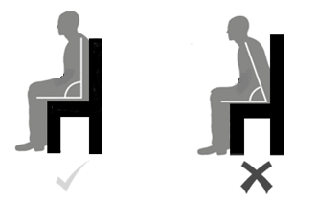

* Avoid crossing your legs at your ankles or knees
* Do not twist
* Avoid bending your hip more than 90 degrees during any activity
* Sleep on your back or on the opposite side to your operated leg with a pillow between your knees to prevent your leg crossing or twisting
* Do not have less than 90° between your body and thighs i.e. avoid bending your body down towards your feet, or lifting your operated leg towards your body
* Avoid attempting to climb in or out of your bath for the first 6 weeks.
* It is advisable to wait 6 weeks before attempting sexual intercourse.

To make sure you adhere to your precautions we need to assess the heights of your furniture at home to check they are high enough for you. We therefore need you to send the following information, via email, to [**joint-info@uhnm.nhs.uk**](mailto:joint-info@uhnm.nhs.uk)

1. **Height of your bed and chair at home**: do these when they are compressed, from the top of the seat or mattress, down to the floor
2. **Height of your toilet(s), from the top of the bowl to the floor**
3. **Height of any other seats at home including stair lifts if used**

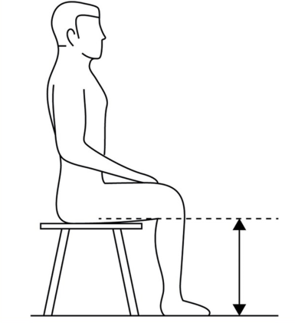4. **Knee to floor height:** please also get someone to take a measurement from the back of your knee to the floor. The measurement needs to be taken with shoes/slippers off and taken from the crease at the back of your knee to the floor (as per image)

Please see the patient advice video for additional advice on how to take these measurements and demonstrations how to complete this.

**The Operation Day**

You will be admitted to the ward at 7am on the day of your surgery.

|  |
| --- |
| **Please make sure you adhere to the day case fasting guidelines:**   * No food within 6hours of admission * Coffee/tea with a dash of milk up to 2hours before admission * Water permitted until taken to surgery |

On the morning of your surgery you will be reviewed by multiple members of the multidisciplinary team including anaesthetists, nurses etc. to prepare you for your surgery.

Dependent on your position on the theatre list, you may be reviewed by a member of the therapy team prior to your surgery to practice mobilising with crutches.

Day case hip replacements are done under a spinal anaesthetic, meaning that you will be awake for your surgery but numb from your waist down. You will be offered a sedative alongside this.

Post operatively you will be transferred back to the ward and have something to eat and drink in preparation for mobilising. **Remember eating and drinking well post operatively is essential to prepare you to mobilise early.**

As soon as your spinal anaesthetic block has worn off, **you will be seen by the therapy team to get up and mobilise, likely within about 4hrs from your surgery.**

It is normal for you to experience discomfort after your surgery and for your surgical site to feel tight and sore. Make sure you ask for regular recovery medication as this will aid your progression.

You will be taught exercises to complete post operatively which aim to start to get your leg moving and muscles working after your surgery. Try to complete these regularly throughout the day.

The therapy team will teach you how to transfer in and out of bed and will complete a stair assessment if required before going home.

**Total Hip Replacement Exercise Guide**

The information in this guide will help you with the exercises and your mobility plan which you need to do following your operation.

|  |
| --- |
| The exercises may be uncomfortable at the start, so work to a level of discomfort that is acceptable to you.  Please speak to a member of staff if you are not able to perform the exercises as it may be that your recovery medication needs to be reviewed.  Please **complete the following exercises** a **minimum of 3-4 times** throughout the day as this aids recovery and will reduce the likelihood of any complications following your surgery.  **Bed exercises.** Start these exercises as soon as you can move your leg after surgery.  **Chair exercises**. Start these exercises with a member of staff once you have got out of bed. |

**Exercises**

1. **Static Quad**

|  |  |
| --- | --- |
|  | **Lying down on the bed:**   * Keep the leg that has been operated on straight and pull your ankle towards you. * Push the back of your knee into the bed. * Tighten your thigh muscle. * **Hold for 3 seconds.** * **Repeat 10 times**. |

|  |  |
| --- | --- |
|  | **Sitting in a chair:**   * Sit on the edge of the chair. * Straighten the leg that has been operated on. * Pull your ankle towards you and tighten your thigh muscle. * **Hold for 3 seconds.** * **Repeat 10 times.** |

1. **Static Gluteus**

|  |  |
| --- | --- |
|  | **Lying down on the bed:**   * Keep both your legs out straight. * Squeeze your bottom muscle together. * **Hold for 3 seconds.** * **Repeat 10 times.** |
|  | **Sitting in a chair:**   * Keep your feet flat on the floor. * Squeeze your bottom muscles together. * **Hold for 3 seconds.** * **Repeat 10 times** |

1. **Hip Abduction**

|  |  |
| --- | --- |
|  | **Lying down on the bed:**   * Keep both your legs out straight. * Whilst keeping your heel on the bed, bring the leg that has been operated on out to the side, then bring back to mid position. * Make sure that you do not cross the midline point of your body. |

1. **Knee Extension**

|  |  |
| --- | --- |
|  | **Sitting in a chair:**   * Sit with your feet flat on the floor and your knees bent. * On the operated leg, start to straighten your knee fully, pulling your ankle towards you. Aim to lift your foot off the floor. * Return to the starting point. * **Repeat 10 times.** |

1. **STS from chair**

|  |  |
| --- | --- |
|  | **Sitting in a chair:**   * Sit on the edge of the seat with your feet flat on the floor. * Push up into standing and fully straighten knees and hips. * At first you may need to use the arms of the chair to do this. Progress this exercise by not using the arms of the chair. * Aim to keep the weight equal through both legs. * **Repeat 10 times.** |

**Mobility and Elbow Crutch Technique**

|  |
| --- |
| Mobilising is essential to aid your recovery and reduce your risk of post-operative complications.  You will be assessed by the therapy team and provided with an appropriate walking aid. **It is expected that you will continue to mobilise outside of your therapy sessions to build your confidence ready for discharge home.**  Use your own judgement as to whether you need support whilst mobilising on the ward or discuss with your physiotherapist. **Aim to mobilise regularly every 1-2 hours whilst awake and build your distance each time ready for home.** |

**Mobility**

|  |  |
| --- | --- |
|  | * Place the crutches in front of you, shoulder width apart. * Step your operated leg forwards followed by the un-operated leg stepping just behind the elbow crutches. Repeat. * To progress, try to walk as normal as possible by stepping one foot past the other in a normal walking pattern. * As you feel comfortable, progress to one walking aid. To do this place the elbow crutch on the opposite side to your operated leg. You can progress to no walking aid as appropriate. * If you start to walk with a limp or find yourself leaning, go back to using your walking aid. |

**Stairs**

Diagrams – ©Physitrack

|  |  |
| --- | --- |
|  | **Using a handrail**   * Remove the crutch on the same side as the rail. * Place the crutch on the outside of the other crutch in the shape of a ‘T’ as indicated in the picture. * Place your free hand on the rail. |
| **Going up**   * Un-operated leg * Operated leg * Crutch | **Going down**   * Crutch * Operated leg * Un-operated leg |
|  | **Without a handrail**   * Keep hold of both crutches.   . |
| **Going up**   * Un-operated leg * Operated leg   Crutches | **Going down**   * Crutches * Operated leg   Un-operated leg |

Diagrams – ©Physitrack

**Total Hip Replacement Sit to Stand Technique with elbow crutches**

|  |
| --- |
| Always remember to remove elbow crutches before sitting down. Please use the techniques below to support with this. |

**To Stand (‘H’ Technique)**

1. 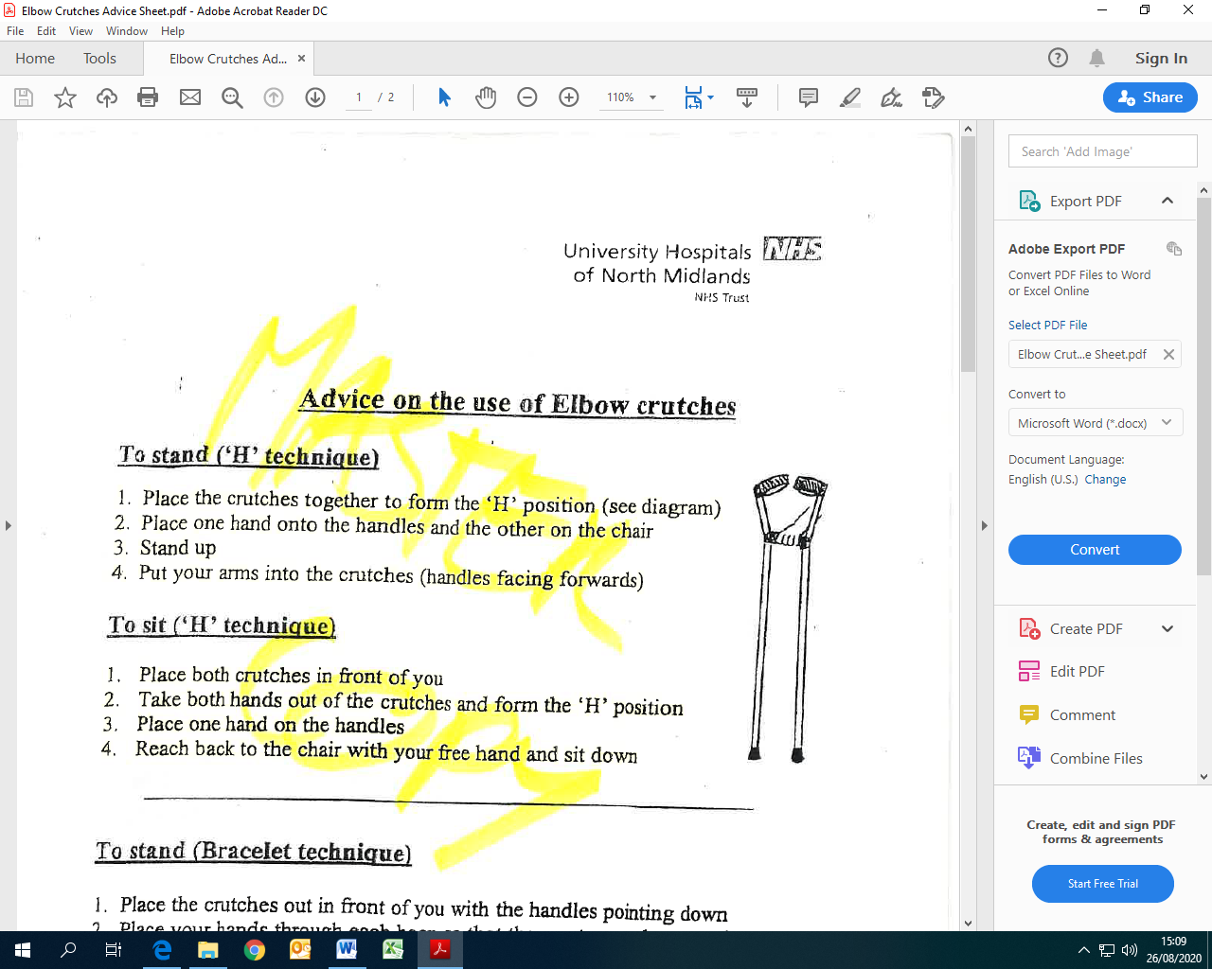Place the crutches together to form the ‘H’ position (see diagram).
2. Place one hand onto the handles and the other on the chair.
3. Stand up.
4. Put your arms into the crutches (handles facing forwards).

**To Sit (‘H’ Technique)**

1. Place both crutches in front of you.
2. Take both hands out of the crutches and form the ‘H’ position.
3. Place on hand on the handles.
4. Reach back to the chair with your free hand and sit down.

**To Stand (Bracelet Technique)**

1. Place the crutches out in front of you with the handles pointing down.
2. Place your hands through each hoop so that they rest around your wrists.
3. Without holding the handles, push up from the arms of the chair (see diagram).
4. Once standing turn the handles forwards.

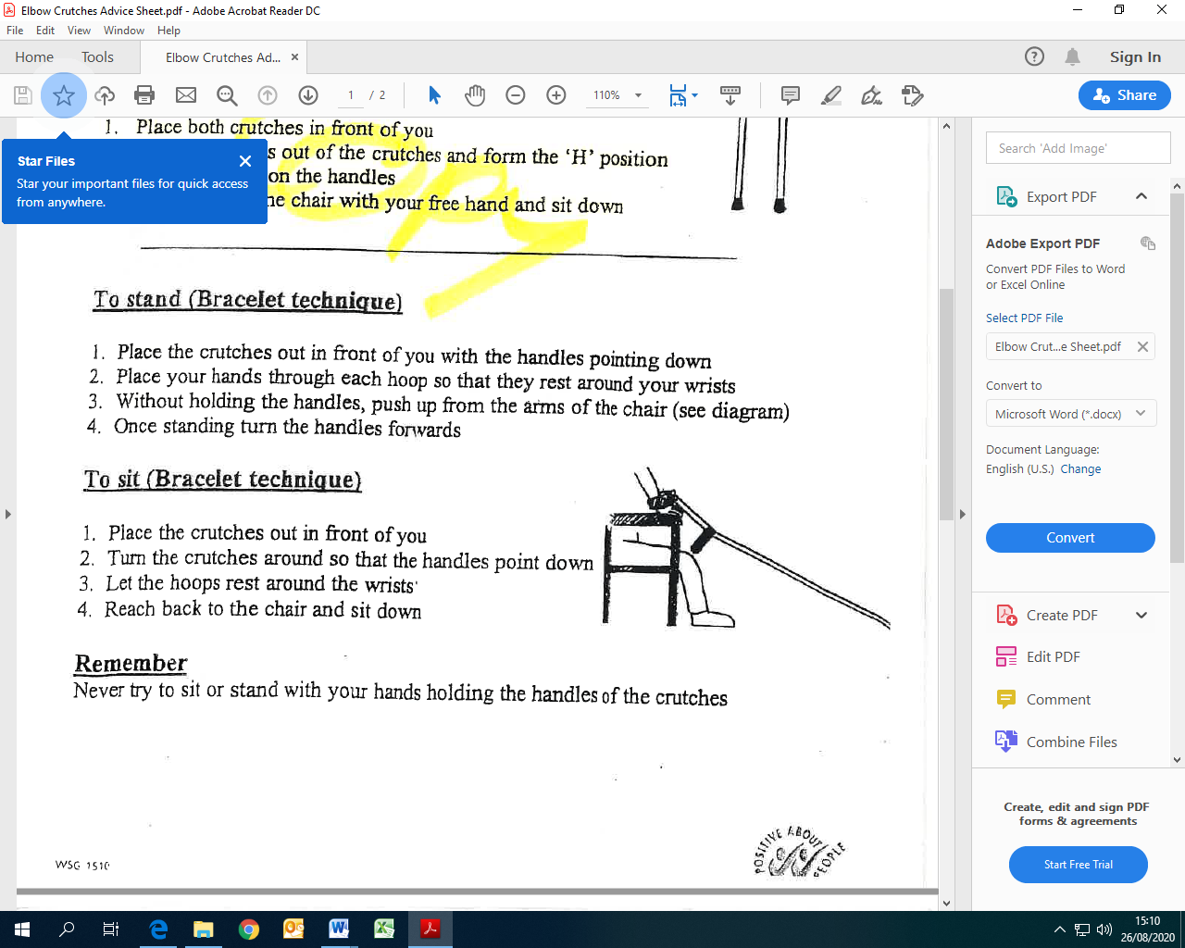**To Sit (Bracelet Technique)**

1. Place the crutches out in front of you.
2. Turn the crutches around so that the handles point down.
3. Let the hoops rest around the wrists.
4. Reach back to the chair and sit down.

**Total Hip Replacement Exercise Progression**

|  |
| --- |
| Once you feel able to you can progress to these exercises.  You can still complete the chair exercises but try to focus more on the exercises below.  Everybody is individual and some of you will complete these exercises easily and some of you may find these more challenging.  Please work at your own pace as everyone’s recovery journey is personal to them.  **For all the exercises stand tall and use support if required.** |

**6. Mini squat**

|  |  |
| --- | --- |
|  | * Bend your knees as if you were sitting down. * Hold for 5 seconds. * Return to the start position. * Keep your weight equal through both feet. * **Repeat 10 times.** |
| **As this becomes easy, you can progress by bending your knees further to increase your range of movement and build up the strength in your legs.** | |

1. **Standing calf raise**

|  |  |
| --- | --- |
|  | * Keep your knees straight. * Lift your heels off the floor and rise up onto your toes. * Hold for 5 seconds. * Return to the start position. * **Repeat 10 times.** * You can progress this by standing on your operated leg only. |

1. **Step up**

|  |  |
| --- | --- |
| **If you have stairs or an appropriate step you can complete the following to further strengthen your leg.** | |
|  | * Lift your operated leg onto the step bringing your un-operated to meet. * Step back down with your un-operated leg first followed by your operated leg. * The aim of this exercise is to increase your strength and confidence leading with the operated leg. * To progress the exercise, you can reduce the amount of support you are using. |

1. **Side step**

|  |  |
| --- | --- |
|  | * Stand up straight with your feet hip width apart. * Step your operated leg sideways, followed by the un-operated leg. * **Repeat this 10 times in each direction.** * To progress the exercise, you can reduce the amount of support you are using. |

Diagrams – ©Physitrack

**Getting in & out of a car after your Total Hip Operation**

**Preparation**

* Park at least 2 feet away from the kerb
* Put the front passenger seat as far back as possible
* Recline the backrest of the seat as pictured

**Getting in to the car** (depicted by white arrow)

1. Stand next to the car, turn, and step back until you can feel the car seat behind both legs, give walking aids to driver

2. Place hands on car seat and dashboard for support, position your operated leg forwards to ensure you do not bend past 90 degrees

3. Gently lower yourself down, once sat bring your legs round together and position them in the foot well

Fasten seat belt and have a pleasant journey

**Getting out of the car** (depicted by black arrow)

1. Ensure preparation has been followed, begin by moving bottom towards edge of seat, and then bring both legs out of the car together

2. Again move to the edge of the seat, position operated leg out in front to ensure you do not bend past 90 degrees

3. Stand up by pushing through your arms, gain your balance and ask your driver to pass your walking aids to you



**Getting into a car safely**

**Getting out of a car safely**

**Discharge home**

|  |
| --- |
| Once you have achieved all your milestones for discharge you will be discharged home usually around 7-8pm.  **Please make sure you arrange for family or friends to collect you from the hospital.** |

You will be provided with a recovery medication pack to take to keep your discomfort levels manageable in the early days post operatively. All new medications will be explained to before you are discharged.

On the day following your surgery, you will be contacted by a member of nursing staff to check you are recovering well and discuss any concerns you may have.

**What can you do to help recovery in the early stages?**

During the early stages at home, it is normal that your discomfort levels, stiffness and movement and exercise tolerance to fluctuate.

It is common to have some generalised swelling of your leg below your replacement. You may need to rest on the bed for at least 30mins a few times a day initially to help reduce your swelling. If you have increased swelling and pain, please seek medical advice.

It is important to pace yourself with exercises and mobility – by doing little and often dependent on how you feel and keeping on top of your recovery medication.

It is ok for you to progress your mobility and build up as able. You can try to walk as normally as possible by placing one foot past the other in a normal walking pattern. As soon as you feel able you can progress to using one walking aid on the opposite side your surgery. If you start to walk with a limp or leaning, go back to using your walking aids.

Aim to complete the exercises taught on the ward 3-4 times per day as these will help to improve the movement and strength around your hip.

You will be referred to the appropriate therapy teams to continue with your rehabilitation on discharge. They will advise you further on increasing your mobility and returning to normal everyday activities.

**Support on Discharge**

The following day after your surgery, you will be contacted by a member of nursing staff to find out how you are managing after your surgery, to discuss your recovery medication and offer any further advice should you require it.

**Therapy Support**

Should you have any questions regarding your therapy or concerns regarding your home situation or how you will cope after your surgery, please contact our therapy team on [joint-info@uhnm.nhs.uk](mailto:joint-info@uhnm.nhs.uk) and a member of the team will get back to you. Please include your full name, date of birth and unit number or NHS number if known on any correspondence to this email address. This email is monitored by several members of the therapy team at UHNM, throughout the week.

**Patient Education Video**

We have developed a patient education video to help prepare you for your surgery. Please scan the QR code or follow the link to:



**Additional useful resources:**

**Versus Arthritis**: https://versusarthritis.org/about-arthritis/exercising-with-arthritis/lets-move-for-surgery-toolkit/