

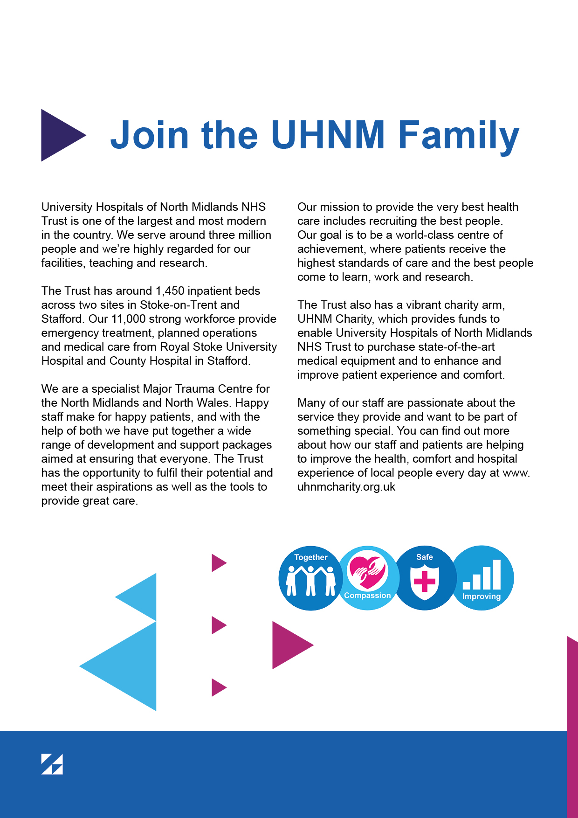

**Values & Promises**

We have four core values and promises that were co-created by our staff, patients and carers.

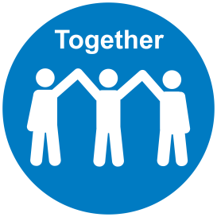**Together**

* We are a Team – I will be considerate, help others to achieve our goals and support others to make positive changes
* We are Appreciative – I will acknowledge and thank people for their efforts and contributions
* We are Inclusive – I will be open and honest, welcome people’s views and opinions and involve people in decisions that affect them

**Compassion**

* We are Supportive – I will be empathetic and reassuring. I will support and encourage people when they need it
* We are Respectful – I will treat people fairly, with respect and dignity, protect their privacy and help them to feel comfortable
* We are Friendly – I will be welcoming and approachable. I will make eye contact, say hello and introduce myself #hellomyname is

**Safe**

* We Communicate Well – I will explain clearly, share relevant and timely information and keep people updated
* We are Organised – I will plan ahead, manage my time well and be prompt in what I do
* We Speak Up – I will contribute to ensuring healthy and constructive feedback for all so we can feel safe to challenge inappropriate care and behaviour and promote our values

**Improving**

* ****We Listen – I will welcome people’s views and ideas, invite people to ask questions and share their opinions and respond to what I hear
* We Learn – I will share best practice, celebrate good performance and support others to use their skills, learn and grow
* We Take Responsibility – I will have a positive attitude, act and encourage people to take the initiative and make improvements

**Division: Therapies**

**Job Title:** Senior Occupational Therapist

**Band:** 6

**Location: Royal Stoke/County**

**Hours: 37.5**

**Managerially accountable to: Divisional Therapy Managers, Principal Therapists, Advanced Therapists**

**Professionally accountable to: Divisional Therapy Managers, Therapy Team & All members of the multi-disciplinary team patients, relatives and Carers**

**Role Summary**

**This role undertakes nine monthly rotations through the clinical speciality in which the individual is employed, where this is practical. This role works autonomously as an independent practitioner managing the clinical delivery of care within a specialty team and supervises less experienced therapists, support staff and students**

**Key Areas/Tasks**

* To actively participate in ward meetings, ward rounds, case conferences as appropriate.
* Liaise with other agency service providers (including GP’s, Clinics, Community / Outpatients Service, Intermediate Care Team, Equipment Loan Stores, Discharge Team).
* To support and liaise with Band 7 and 8 therapists and Team Leaders.
* To use motivational and negotiation skills in the treatment of patients in your specialised area to gain consent and compliance with treatment particularly where patients have significant barriers to communication e.g. dementia, cognitive impairment, behavioural problems low awareness state.
* To deliver and receive complex and sensitive information to and from patients, professional colleagues and other members of the multi-disciplinary team.
* To use analytical and problem solving skills to interpret complex information from a variety of sources e.g. medical notes, diagnostic tests and clinical investigations.
* To interpret, analyse and evaluate results to form a progressive therapy treatment plan with due consideration to contraindications and precautions, liaising with more experienced staff for advice
* To plan, manage and prioritise own caseload and delegate work appropriately to band 5 staff,
* To make customised splints or casts for patients using e.g. thermoplastic materials. Dexterity and speed required ensuring correct alignment of joints and placement of the splint before the material hardens.
* To use manual and mobilising skills in the assessment and treatment of patients
* To provide cover for other teams within the Directorate based on your knowledge, skills and competencies in order to meet changing priorities and service demands.
* To decide if further therapeutic intervention is required following a patients discharge from hospital and to arrange as necessary
* To select treatment techniques with awareness of the relative benefits and risks of that intervention.
* To educate patients and their relatives / carers about their condition and its significance and ensure that care information and support is available.
* To plan, implement and evaluate treatment plans for patients who may have complex needs including physiological, psychological and social factors, reviewing and adapting treatment plans to suit the patients’ individual needs. Intervention will include discussion with the patient and / or relatives / carers regarding the impact of a diagnosis and the outcome of planned therapy treatment
* To ensure that suitable equipment and materials are selected and properly used and that staff, patients and carers are appropriately trained.
* To carry out specialised assessments, procedures / techniques which may / may not involve use of equipment?
* To undertake bank holiday / weekend work across 2 Trust sites including working unsociable hours and lone working.
* To work towards national and locally agreed standards of service.
* To contribute to service development in liaison with the Team Leaders
* To participate in the development and implementation of quality initiatives including standards of patient care, protocols, guidelines, clinical audit, research projects and monitoring of service provision in collaboration with colleagues and service users within the remit of the post
* To be flexible and adapt to the changing needs of the Therapies Department.
* To keep accurate and up to date patient records, documentation and statistical information following local and national guidelines.
* To access and input to manual and electronic information systems.
* To assist in the evaluation of current practice including the use of audit, research and development, protocols, guidelines and standards for change and contribute to service development.
* To adhere to the relevant professional code of ethics and code of professional conduct.
* To undertake assessment and treatment of patients on a daily basis,using manual handling techniques in the rehabilitation of patients working within Trust, Directorate and professional policies, guidelines and protocols
* To move and handle equipment on a daily basis e.g. hoists, wheelchairs, assistive equipment (e.g. walking aids, toilet seats)
* To concentrate for up to 1-2 hours at a time through the shift whilst reading, interpreting and analysing patients notes, preparing reports, carrying out assessments and treatments and when documenting treatment interventions, outcomes, analyses and plans
* To carry a bleep and to change from one activity to another at short notice e.g. to manage staff issues, meet changing clinical or work demands
* To respond appropriately in an emergency situation in case of cardiac / respiratory arrest, on acute deterioration of a patient’s condition during therapy intervention.
* To work in highly challenging, distressing or emotionally charged situation providing treatment to critically ill, deteriorating or terminally ill patients and support others in that environment.
* To deliver unwelcome or hard to accept information to patients and carers, for example, relating to limited rehabilitation outcomes and inability to return to previous home environment.
* To give consideration to and manage the emotional and psychological requirements of patients (and their carers) who have a chronic, acute or terminal diagnosis or who are going through a bereavement following e.g. loss of a limb or functional ability.
* To manage patients who may present with infectious diseases, or need special consideration with regards to coping with bodily fluids.
* To work in a highly unpleasant environment with frequent daily exposure to body fluids, including sputum, sick, urine and faeces (and dealing with these as appropriate) and occasional exposure to verbal or physical aggression.
* To undertake work in the patient’s home environment as necessary with due regard to the issues potentially compromising safe working practice e.g. working in restricted spaces

**Personal/Professional Development**

* To take every reasonable opportunity to maintain and improve your professional knowledge and competence
* To participate in personal objective setting and review, including the creation of a personal development plan and the Trust’s appraisal process.

**Health and Safety**

* To take reasonable care for your own Health and Safety and that of any other person who may be affected by your acts or omissions at work.
* To co-operate with University Hospitals of North Midlands (NHS) Trust in ensuring that statutory regulations, codes of practice, local policies and departmental health and safety rules are adhered to.
* To comply and adhere to individual and role specific responsibilities as stated in the Trust Health and Safety Policy (HS01) and all other Health and Safety related policies.

**Equality and Diversity**

UHNM is committed to the implementation of the Equality, Diversity and Inclusion Policy

Which ensures equal opportunities for all. UHNM is also committed to embracing diversity

and eliminating discrimination in both its role as an employer and as a provider of services.

It aims to create a culture that respects and values each other’s differences, promotes

dignity, equality and diversity and encourages individuals to develop and maximise their

potential. All staff are required to observe this policy in their behaviour to other workers and

patients/service users

**Infection Prevention**

Infection Prevention is the obligation of every employee both clinical and non-clinical at the University Hospitals North Midlands NHS Trust. Driving down healthcare associated infection is everyone’s responsibility and all staff are required to adhere to the Trust’s Infection Prevention policy

All staff employed by the UHNM Trust have the following responsibilities:

**Trust Dress Code**

* Trust approved uniform/dress code must be adhered to
* When in clinical areas **all** staff must be bare below the elbow, without wrist watches, stoned rings, wrist jewellery, false nails, nail polish or plaster casts
* No personal bags to be worn during clinical duties

**Hand Hygiene**

* Decontaminate your hands as the per ‘The five moments of hand hygiene’

**Own Practice**

* Lead by example
* Encourage and praise good practice
* Be prepared to accept advice about your own practice

**Decontamination**

* Ensure that equipment you have been using or about to use has been decontaminated effectively
* Ensure that you are aware of the Trust approved cleaning products, and follow a safe system of works

**Trust Policies**

* Ensure that you know and strictly follow relevant Infection Prevention policies for your role and apply standard precautions at all times, which is available in the Infection Prevention Manual on the UHNM intranet

**Data Protection Act, General Data Protection Regulation (GDPR) and the NHS Code of Confidentiality**

All staff are responsible for ensuring they are familiar with and adhere to the Trust’s policies, procedures and guidelines with regards to the Data Protection Act, General Data Protection Regulation (GDPR) and the NHS Code of Confidentiality. This includes confidentiality, information security, cyber security, secondary use and management of records.

Staff have a responsibility in protecting the “rights and freedom” of natural persons (i.e. live individuals) and to ensure that personal data is not processed without their knowledge, and, wherever possible, that it is processed with their consent. Processing includes holding, obtaining, recording, using and disclosing of information and applies to all forms of media, including paper and images. It applies to both patient and staff information

Hence staff must ensure confidentiality is maintained at all times, data is recorded accurately and you only access this information as part of your job role

**Safeguarding Children, Young People and Adults with care and support needs**

All staff are responsible for ensuring that they are familiar with and adhere to the Trusts Safeguarding Children and Adults policies, procedures and guidelines. All health professionals who come into contact with children, parents, adults with care and support needs and carers in the course of their work have a responsibility to safeguard and promote their welfare as directed by the Children Acts 1989/2004 and the Care Act 2014. Health professionals also have a responsibility even when the health professional does not work directly with a child or adult with care and support needs but may be seeing their parent, carer or other significant adult.

All staff are required to attend safeguarding awareness training and undertake any additional training in relation to safeguarding relevant to their role

This job description is not intended to be an exhaustive list and may be subject to change from time to time. All documents referred to throughout this Job Description can be found on the Trust’s intranet, or alternatively copies can be obtained from the Human Resources Directorate

**Sustainability**



Sustainability and Corporate Social Responsibility are fundamental to the way the University Hospitals of North Midlands NHS Trust (UHNM) work.  The Trust has developed a Sustainable Development Management Plan (SDMP): ‘*Our 2020 Vision: Our Sustainable Future’* with a vision to become the most sustainable NHS Trust by 2020. In order to achieve this, we need the support of all staff.  As a member of staff, it is your responsibility to minimise the Trust’s environmental impact and to ensure that Trust resources are used efficiently with minimum wastage throughout daily activities.  This will include minimising waste production through printing and photocopying less, reducing water waste and when waste is produced, it is your responsibility to segregate all clinical waste correctly and recycle. Switch off lights and equipment when not in use, report all faults and heating / cooling concerns promptly to the Estates Helpdesk and where possible minimise business travel.  Where the role includes the ordering and use of supplies or equipment the post holder will consider the environmental impact of purchases.

*SWITCH to a Sustainable UHNM* is a campaign that focuses on the sustainability of the Trust and how we can use resources more effectively to provide better patient care, improve our health and work place. SWITCH is looking to recruit as many Champions as possible to help to bring the campaign to colleagues in their departments / wards and bring SWITCH to life. If you are interested in becoming a SWITCH Champion please contact [switch@uhns.nhs.uk](mailto:switch@uhns.nhs.uk)

**Disruptive Incident & Business Continuity**

The Trust needs to be able to plan for, and respond to a wide range of incidents and emergencies that could affect health or patient care. These could be anything from severe weather to an infectious disease outbreak or a major transport accident.

All staff are required to have an awareness of the Trust’s business continuity arrangements, as a minimum. All staff will be required to;

* To know how to identify a business continuity incident and the method for reporting;
* To have an awareness of local business continuity arrangements;
* To participate in awareness, training and exercises, as required;

In the event of a disruptive incident, all Trust employees will be required to attend work if they are fit and well and able to do so in line with a Trust risk assessment   Those who are clinically qualified will be required to work flexibly across the Trust to meet the service need in clinical areas. This will include front line clinical staff who will be expected to cover alternative duties as and when required in order to ensure that all essential services are maintained.

Signed Employee ________________ Print ________________ Date ________________

Signed Manager _________________ Print ________________ Date ________________

**Senior Occupational Therapist**

**Person Specification**

|  |  |  |  |  |
| --- | --- | --- | --- | --- |
|  | **Specification** | **Criteria** | | **Evidence** |
| **Essential** | **Desirable** |
| **Essential Qualifications** | Degree/Diploma in Occupational Therapy  Registered with HCPC  Evidence of CPD  CPD relevant to speciality area | **✓**  **✓**  **✓**  **✓** | ✓ | Application/Certificate  Application/Certificate  Application/Interview  Application/Interview |
| **Knowledge, Skills, Training and Experience** | Minimum of 18 months post graduate experience as an Occupational Therapist  Experience gained within an acute setting  Experience relevant to specialty area  NHS experience  Experience of supporting/supervising staff  Ability to liaise with other professionals/agencies  Motivated to self-develop  Ability to work as part of a team  Knowledge of interdisciplinary working  Ability to prioritise  Ability to react well to pressure  Able to use initiative/be innovative  Good communicator – verbally and in writing  Involvement in training staff/delivering presentations  Experience of Audits  Clinical educator | **✓**  **✓**  **✓**  **✓**  **✓**  **✓**  **✓**  **✓** | ✓  ✓  ✓  ✓  ✓  ✓ | Application/Interview  Application/Interview  Application/Interview  Application/Interview  Application/Interview  Application/Interview  Application /Interview  Application/Interview  Application/Interview  Interview  Interview  Interview  Application/Interview  Interview  Application/Interview  Application/Interview |
| Personal Qualities | Ability to be flexible and adaptable  Excellent attendance record/reliable  Reliability and trustworthiness  Ability to undertake A&C duties linked to clinical work  Adherence to the Trusts Uniform Policy  Smart appearance | **✓**  **✓**  **✓**  **✓**  **✓**  **✓** |  | Interview  Interview  Interview  Interview  Interview  Interview |