

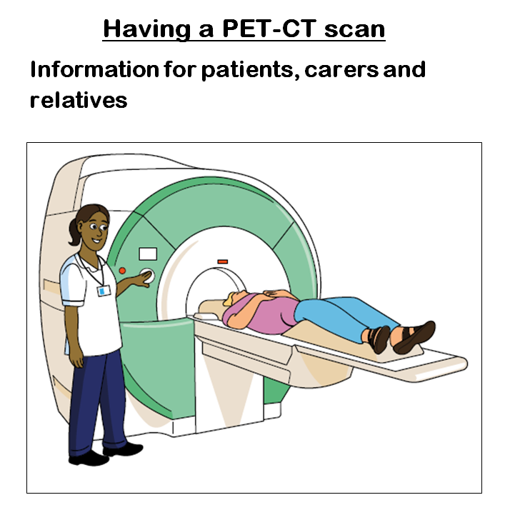


Easy Read


This booklet uses easy words and pictures. You might want to ask someone to help you read it.
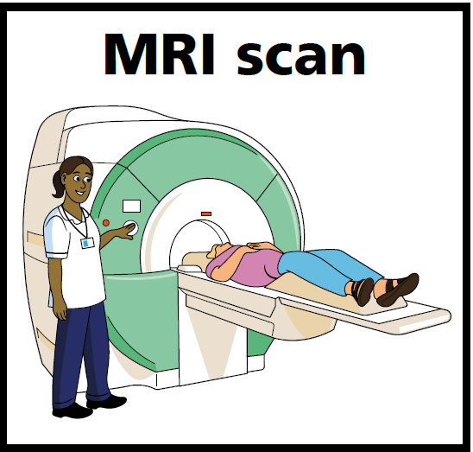
PET scan scan
This booklet is about having a PET scan.
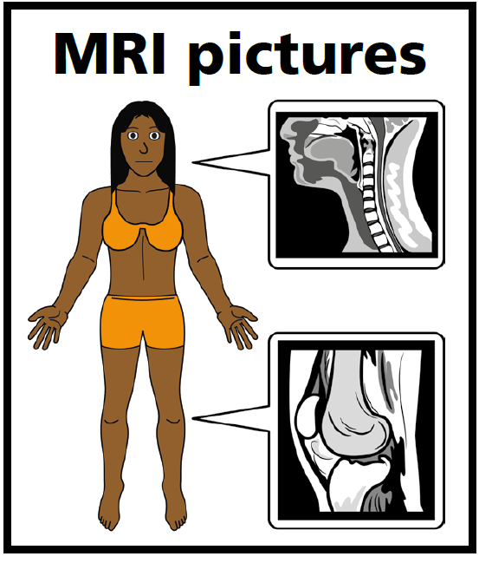
PET Pictures
A PET scan takes pictures of the inside of your body.

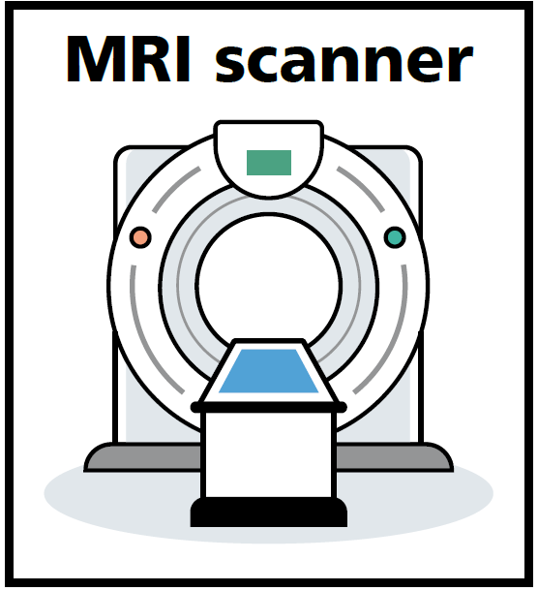
PET scanner
The scanner looks like a big box with a hole in it. It has a special bed for you to lie on.
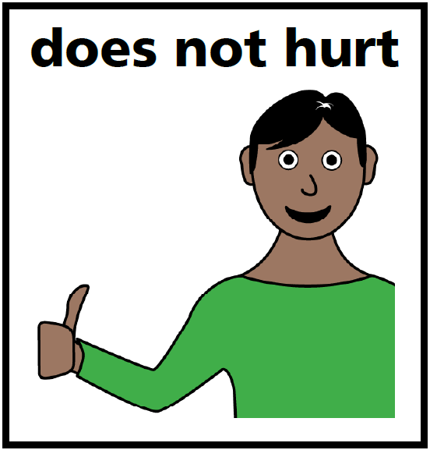
The PET scan does not hurt and is not bad for you.
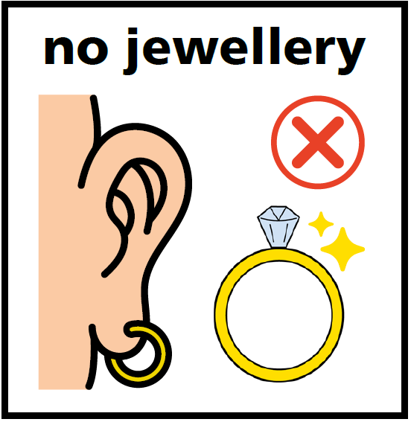
You can’t wear jewellery, hair clips, zips or a bra in the scan.

Do not eat or drink apart from water for 6 hours before the scan.
Do not smoke before the scan.
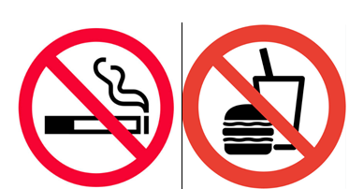

Before the scan you will have an injection. It helps the scan to get pictures.
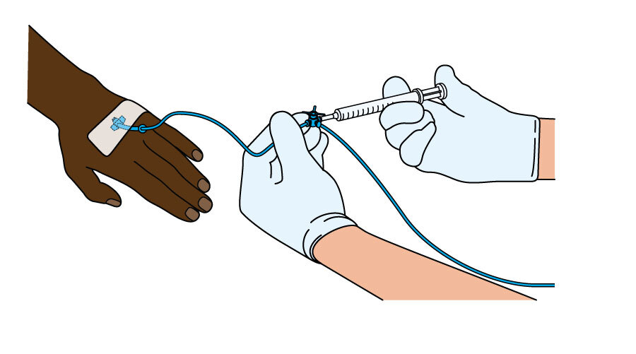

The injection does not harm you or make you sleep.
No harm

After the injection you have to wait one hour before the scan.

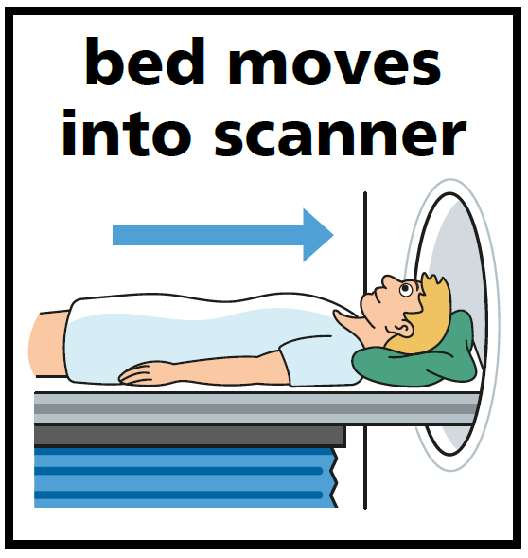
The bed you lay on will move in and out of the scanner. There is lots of space. It is not noisy.
It takes about 30 minutes for the scan to take the pictures.

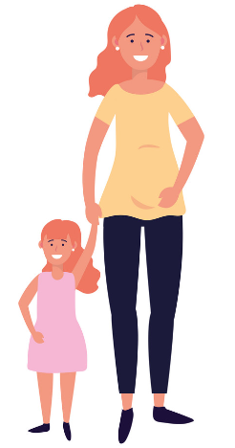
After the scan, don’t mix with pregnant women or young children for the rest of the day.

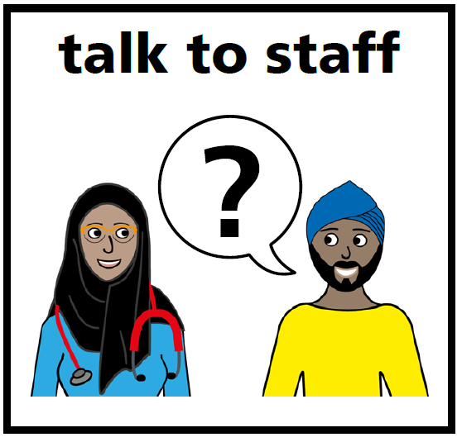
Tell the staff if you are worried or have questions.



LUNGCANCERCNS/PG/UHNM/09/2023

